 [www.mabelcanton.k12.mn.us](http://www.mabelcanton.k12.mn.us) Office Hours: 7:30 am - 4:15 pm * District Secretary Lisa Halverson ext. 101 * District Secretary Heather Kleiboer ext. 102

2022-2023 Mabel-Canton ISD 238

Back to School Newsletter

316 W Fillmore Ave, Mabel, MN

(Phone) 507-493-5422 (Fax) 507-493-5425



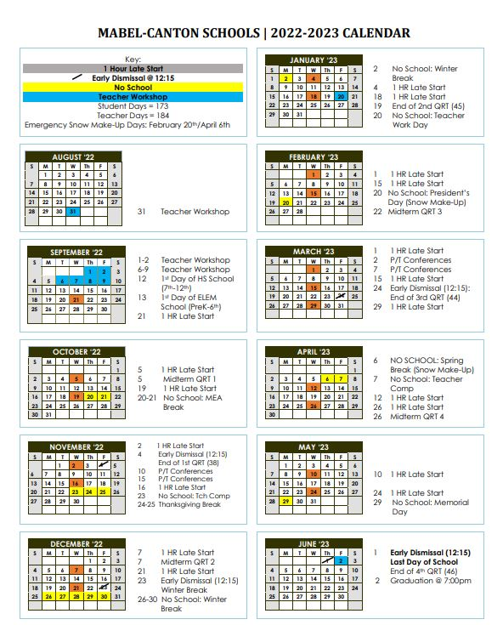

Mabel-Canton Public School

316 W Fillmore Ave

Mabel, MN 55954

[www.mabelcanton.k12.mn.us](http://www.mabelcanton.k12.mn.us)

Ph: 507.493.5422

Fax: 507.493.5425

Box Holder

**Non-profit Organization**

**US Postage Paid**

**Permit #1**

* Business Mgr. ext. 104(April)/105(Aimee) * Principal Michelle Weidemann ext. 106

* Superintendent Gary Kuphal ext. 103

**ANNUAL MABEL-CANTON SCHOOL DISTRICT CLEANUP DAY**

**Community Volunteers Needed Sunday August 28th, 1pm-5pm**

Suggested Ages: 13 and above

Volunteer to help the Mabel-Canton School’s buildings and grounds become more attractive!

*Examples of ways you can help:* Moving items back into classrooms (major focus) in addition to light cleaning, landscaping/weed-eating, interior painting and other projects to be determined.

Please sign-up by calling and leaving a message with the front office (507-493-5422) or emailing Superintendent Gary Kuphal ([gkuphal@mabelcanton.org](mailto:gkuphal@mabelcanton.org)) or Principal Michelle Weidemann ([mweidemann@mabelcanton.org](mailto:mweidemann@mabelcanton.org)). Sign-up preferred but all are welcome.

**SAVE THE DATE!**

**The first day of the 2022-2023 school year for Mabel-Canton Elementary students and parents will be like prior years.**

***High school will start on Monday, Sept. 12th***

**The first full day of school for all students preK-6 will be *Tuesday, September 13th.***

**On Monday, Sept. 12th, students in grades K-6 will be invited to meet with their teacher individually for approx. 20 minutes for literacy assessments, if you did not do this during Back to School Night.**

**To sign up your child for**

**Back to School Conferences/Assessments, please go to the school website “*News” section.***

**\*\*\*Athletic/Extra Curricular Eligibility Meeting Dates: Aug. 10th and 16th at 6:30 pm in the High School Gym, Mabel, MN\*\*\***

***Athletic Fees for 2022-23***

(per student/per sport)

Grades 6-8 $35.00

Grades 9-12 $50.00

Family Max $160.00

**Back to School Night 2022**

**Wednesday, Sept. 7th, 2022 in the MC High Gym, 3:30-6:30 pm**

**> 6 pm Freshman/New Student Orientation**

**> School Photos will be offered from JOSTENS this year during Back to School Night. Look for more info on the website soon!**

**> Teachers and Staff will be available to help you throughout the school.**

**> Our Transportation Manager will be there. New Families-stop by and get your family on the bus route, or let him know of any changes!**

***Season Tickets*** *are now available! You can purchase tickets to all HOME non-tournament MC athletic events in the office.*

***Student Pass $35.00***

***Adult Pass $55.00***

***Senior (55+) Pass $35.00***

***Family Max Pass $160.00***

**Game day ticket Prices:**

**$4 for Students/Seniors**

**$6 for Adults**



Information you can find on our school website:

Student Handbooks, Supply Lists, Annual Notifications on indoor air quality, pesticide notice, district policies, plus much more!

Upcoming Announcements are also posted on our website.

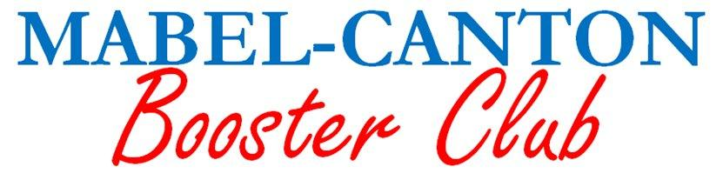 The Mabel-Canton Booster Club is seeking active members and volunteers!

The M-C Booster Club is a 501(c)3 organization designed to support the M-C School district and its students. Meeting just once a month, the M-C Booster Club is a great way to get involved. They are also looking for volunteers to be called upon to assist with events throughout the year without the monthly meeting commitment. This is open to anyone in the community, not just parents! To become a member or be added to the volunteer list, stop by the M-C Booster Club table at Back-to-School Night, and be sure to like us on Facebook!

Cougar Gear is available throughout the year during home events and at the Craft show in November.  You can also email us at [mabelcantonboosters@gmail.com](mailto:mabelcantonboosters@gmail.com) for more information.

A few things the M-C Booster Club has donated to:

Weight room, National Honor Society, Snowball dance, Track & Field day ribbons, Senior Scholarships, Choir Awards, Senior Awards, Yearbook Sponsor, Ski Trip Bus, Post Prom, Baseball Helmets, FB and VB Teams, Mabel Area Food Shelf, Community Night Out, HS Science Class, Summer Rec, Trap Team, Basketball books, and much more!

If you want to help make a difference in our student’s futures, consider becoming a part of the MC Booster Club!



**Mabel-Canton Back to School Newsletter 2022**

**Every Child Succeeds Act (ESSA)**

The federal ESSA, formally known as the No Child Left Behind (NCLB) Act of 2001 gives parents of students attending Title I schools the right to know certification information about the teachers and paraprofessionals who work with their children.

The law requires schools to notify parents when their child has been assigned or taught for four or more consecutive weeks by a regular or substitute teacher of a core academic subject who is not highly qualified (as defined by NCLB) in the subject (s)/ level (s) s/he is currently teaching. The teacher currently assigned to your child’s classroom may be certified in a different subject/level from the one s/he is currently teaching or is a substitute teacher who has been teaching your child for four weeks or more.

Please be advised that all teachers are provided with ongoing professional development opportunities and are taking coursework to obtain certification in the appropriate field. In addition, each teacher’s service is reviewed throughout the year and rated annually. This rating covers content knowledge as well as overall teaching methods and ability. If you require further information about the status of the teacher (s) to whom your child is currently assigned, please contact the principal.

**Immunizations:**

The State of Minnesota requires that all public school students **MUST** be current with immunizations *and* have a copy of their records on file at the school district for the year 2022-2023.

All Mabel-Canton students must have proof of up-to-date shots from your medical facility on file by September 19th or the student(s) will not be allowed to attend school until this information has been provided.

 Call the school health office if you have questions at 507-493-5422 ext. 109.

School Age Care (SAC)

Interest Survey:

Please go to our school website at [www.mabelcanton.k12.mn.us](http://www.mabelcanton.k12.mn.us) and on the Homepage, look for the link **in the NEWS section**. Click there to access the survey. Survey deadline: Monday, August 23rd, 2022.



Changes in the Lunch Program:

**This school year (2022-2023) there will no longer be district-wide free meals. Breakfast and lunch (unless you qualify) will no longer be free.**

If your child takes any ‘extras’ during lunch, you will incur a charge for those extra items. If you do not want your child to take extras, please have that conversation with them ahead of time. Please do your best and help the school by keeping your child’s lunch account with a positive balance.

If you have qualified for Free/reduced lunch in the past, or your income has been impacted by COVID19 or has changed, please consider filling out the Educational benefits form included with this letter. It not only helps your family, but can also help the school obtain additional funding. Your forms are kept confidential with the Business office. If you have any questions or concerns with this information, please contact Aimee Lake, Business Manager at 507-493-5422 ext. 105 or email [alake@mabelcanton.org](mailto:alake@mabelcanton.org).

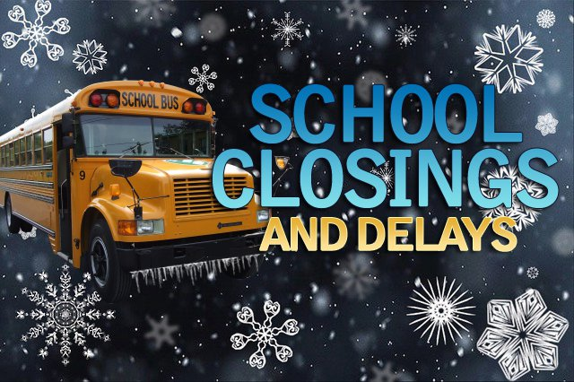

**School Closings**

In the event that school is cancelled, delayed, or dismissed early, the following stations will broadcast that information:

**Radio: WIZM (93.3) KVIK (104.7)**

**TV: KTTC (TV 10)**

**It will also be posted on the school website**: <http://www.mabelcanton.k12.mn.us>

You can also sign up for FREE TEXT ALERTS by texting

this message: @mcalert

to # 612-284-1949

**Early Childhood Back to School Info**

The 2022-2023 school year is right around the corner. Preschool classes will start the week of **September 13th**. We are planning on having one 3 year old class which will be held on Tuesday/Thursdays mornings. Pre-Kindergarten classes will meet on Monday, Wednesday, and Fridays. There are limited spots available for all classes starting in the fall. Families with children already enrolled in preschool for this fall will receive a letter and supply list in the next couple of weeks.

ECFE’s (Early Childhood and Family Education) Family Fun Nights will start in late September/early October. More information will be available in the fall Mini-Cubs Newsletter that is for our M-C families with young children.

Mrs. Hoscheit would like to invite all families with young children to check out our classroom on the back-to-school night on Wednesday, Sept. 7th. If you are interested in registering for preschool or have any questions about our preschool program please contact her at school.

We hold screenings twice a year (Nov/March). We will contact you at a later time to schedule your child’s Early Childhood Screening. If you have any questions, please contact Mrs. Hoscheit [ahoscheit@mabelcanton.org](mailto:ahoscheit@mabelcanton.k12.mn.us) 507-493-5423 ext 127.



**Are you an MC Student in grades**

**7-12 and interested in FFA, or are you already a member?**

Join us to Kick off the year on ***Sunday, Aug. 28th at 5 pm at the Steam Engine Grounds*** for some fun, food and get your Hog Raffle Tickets!

**Mabel-Canton Hot Lunch Information**

Educational Benefits/Lunch Applications are available for pick up at the school office, and are also online. **Students who qualify for reduced-price school meals will receive free lunches and breakfasts; and all kindergarten students qualify for free breakfasts.**

**Families who qualify for free/reduced meals are reminded that students are charged for anything extra the student takes with meal (extra milk or extra ala cart items.)**

Students may bring a check for lunch to the school on Back to School Night, or send money the first day of school. You may deposit as much as you wish and will be reminded when your balance is getting low by email (if you provide an address) or a paper notice on Thursdays. All deposits are to be made before 9 am to be reflected on your child’s account for that day, otherwise their account will not be credited until the next day.

**2022-2023 Food Prices**

**Kindergarten Breakfast                           FREE**

**Grade 1-12 Breakfast                           $1.80**

**Extra Entrée $1.70**

**Adult Breakfast                                 $2.60**

**Extra Milk                                         $  .70**

**Guest Breakfast $2.60**

**Elementary Lunch                            $2.75**

**High School Lunch                            $2.85**

**Reduced Price Lunch $ .00**

**Adult Lunch                                        $4.60**

**Extra Entrée $2.25**

**Kindergarten Milk Break             $50.00/year**

**$25.00/Semester**

**Gr. 1-6 Milk Break                      $80.00/year $40.00/Semester**

**When paying for Milk Breaks-Please write MILK BREAK in the memo. Thank you!**