Lester Prairie School District
Safe Learning and
Preparedness Plan 2022-23

Advisory Committee:

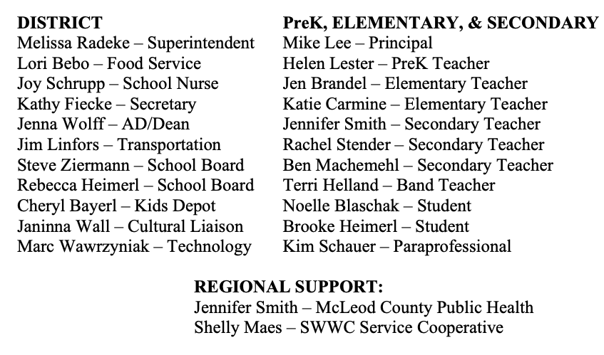
Lester Prairie School District is committed to providing a safe and healthy workplace and learning environment for all students and staff. To ensure we have a safe and healthy workplace, Lester Prairie School District has developed the following Safe Learning and Preparedness Plan. The Safe Learning and Preparedness Plan is administered by Lester Prairie School District, who maintains the overall authority and responsibility for the plan. We have involved our staff and families in this process by listening to and surveying them about concerns, questions, and individual needs.
Lester Prairie School District’s Safe Learning and Preparedness Plan follows the guidance developed by the state of Minnesota, which is based upon Centers for Disease Control and Prevention (CDC); Minnesota Department of Education (MDE); Minnesota Department of Health (MDH); Minnesota State High School League (MSHSL); Minnesota Occupational Safety and Health Administration (MNOSHA) statutes, rules, and standards; and any relevant executive orders.
The Preparedness Plan addresses:
- ensuring sick staff and students stay home;
- hygiene and source controls;
- building and ventilation;
- cleaning and disinfection;
- communications and training practices; and
- teaching and learning instructional practices at Lester Prairie School District.

Ensure sick students and staff stay home:
School staff and students have been informed of and encouraged to self-monitor for signs and symptoms of illness. Staff and students are encouraged to perform a daily self-check before they enter the building. Students and staff are asked to stay home if they are sick.

Hygiene and Source Controls
- Visitors are required to check in.
- Staff members and students have been instructed on safe hygiene practices.
- Respiratory Etiquette: Staff and students have been instructed to cover their mouth and nose with their sleeve or a tissue when coughing or sneezing, avoid touching their face (particularly their mouth, nose, and eyes) with their hands. Tissues should be disposed of in trash receptacles and hands washed or sanitized immediately afterward.

Workplace building and ventilation protocol
Operation of the school facilities includes necessary sanitation, assessment, and maintenance of building systems, including water, plumbing, electrical, and heating, ventilation and air-conditioning (HVAC) systems. The maximum amount of fresh air is being brought into the workplace, and ventilation systems are being properly used and maintained. Air filters are changed frequently.

Workplace cleaning and disinfection protocol
Regular practices of cleaning and disinfecting have been implemented, including a schedule for routine cleaning and disinfecting of work surfaces, equipment, tools and machinery, vehicles and areas in the work environment, including classrooms, restrooms, break rooms, lunch rooms, meeting rooms, offices, and drop-off and pick-up locations.
Appropriate and effective cleaning and disinfecting supplies have been purchased and are available for use in accordance with product labels, safety data sheets and manufacturer specifications, and are being used with required personal protective equipment for the product.
If a staff member, student, or visitor becomes ill, the Lester Prairie School District will coordinate facility cleaning and disinfecting per CDC Guidelines.

Communications and training practices and protocol
This Safe Learning and Preparedness Plan will be communicated on an ongoing basis as needed. Training will be provided to all staff members. This plan will be updated and posted on the District website.
All staff members, students, and facility users share in the responsibility of implementing and carrying out the various aspects of this plan. Our goal is to create a safe learning environment for all students and staff and that requires full cooperation and collaboration of Lester Prairie District staff, students, visitors, and facility users. Only through this cooperative effort can we establish and maintain the safety and health of our learning community.

Activities and Athletics
Facility Use Contact Information and Application Process
If required by MDH and/or MDE, all users wishing to apply for use of Lester Prairie facilities will submit a Safe Learning and Preparedness Plan. For assistance contact one of the following:
- Activities Department Programs: Please submit your Safe Learning and Preparedness Plan to the Activities Director
  - General Questions: Contact Activities Director
  - Community Education Instructors: Contact Activities Director to work through the Safe Learning and Preparedness Plan
  - Community Education Contracted Services: Please submit your Safe Learning and Preparedness Plan to Activities Director
- Facility Renters:
  - Please submit your Safe Learning and Preparedness Plan to Activities Director as part of your application process.

Teaching and Learning Instructional Practices at Lester Prairie School District:
Protocols for sending a student to the office for illness have been developed and communicated.

Lester Prairie Schools has implemented a 1:1 Chromebooks for all students in 2nd-12th grades and ChromeTablets for all K-1 students.
- Students and parents are required to sign a usage agreement form and pay a minimal User Insurance Fee to receive a device.
- Students 4th-12th are expected to take their Chromebooks home daily.

Student and Staff Expectations:
In the event a school day that requires eLearning, families will be notified by an automated School Messenger message.
- Students will access assignments on student devices via Google Classrooms located on teacher websites. Licensed staff will post learning activities by 8:15AM on the day of an E-Learning Day.
- Staff members will be available during student contact hours to answer student questions and provide guidance via email, Google Meets, and/or Google Classrooms. All E-Learning Day assignments will be due one week after the E-Learning Day. Accommodations for students who receive special education and EL services will be provided.
- An eLearning page is located under the Parents tab on the website with details about eLearning days.

Lester Prairie Schools appreciates the entire community’s support. Questions about our Safe Learning and Preparedness Plan should be directed to the Superintendent.
Certified by:
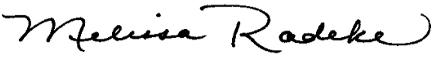
Dr. Melissa Radeke, Superintendent
