**Dundee-Crown**

**High School**



**Coaches Resource Guide**

**2018-2019**

**Introduction**

This Coaching Manual is intended as a resource for all coaches to find information regarding the expectations and administrative procedures for conducting their activities. Nothing in this manual shall be deemed to create contractually or legally enforceable rights. It includes a general overview of procedures for the sport seasons, overall rules and regulations of the athletic department, the National Federation (NFHS), the Illinois High School Association (IHSA), Fox Valley Conference, Community Unit School District 300 and expectations of each of our high school athletic departments.

Your coaching talents are vital to the success of our athletic program, the community and the school. While coaching at Community Unit School District 300, you should act in the best interest of the students and professionally represent your school and community both on and off the field of play.

**Dundee Crown High School**

**Our Mission**

We will provide a high quality education that prepares every Dundee-Crown student for success in college and career.

**Our Vision**

At Dundee-Crown High School we inspire students to dream, persevere, and achieve.

**Our Core Beliefs**

We will value and respect each student and expect their best effort each day.

We will provide opportunities to prepare students for life beyond D-CHS.

We will strive to meet the needs of all learners by building positive relationships and making decisions that encourage their success.

We will collaborate with one another respectfully and professionally as we work to better ourselves.

We will invite parents and community members into the life of our school as they are a valuable asset.

**National Federation of State High School Associations**

**Mission Statement**

The mission of the National Federation of State High School Associations (NFHS) is to serve its members and its related professional groups by providing leadership and national coordination for the administration of interscholastic activities which will enhance the educational experiences of high school students and reduce risks of their participation. The NFHS will promote participation and sportsmanship to develop good citizens through interscholastic activities which provide equitable opportunities, positive recognition and learning experiences to students whole maximizing the achievement of educational goals.

|  |
| --- |
| **Illinois High School Association** |

### IHSA Mission Statement

Adopted on June 9, 2008

The IHSA governs the equitable participation in interscholastic athletics and activities that enrich the educational experience.

Opportunity for boys and girls to represent their school and community as they participate in interscholastic activities is a privilege unique to young people in American education. Why? Because educators across the USA believe that participation in interscholastic activities offers students significant lifetime learning experiences that cannot be duplicated in any other instructional setting.  
  
The purpose of the IHSA is to provide leadership for the development, supervision and promotion of good sportsmanship in interscholastic competition and other activities in which its member schools choose to engage. Participation in such interscholastic activities offers eligible students experiences in an educational setting which provide enrichment to the educational experience.  
  
**It is the responsibility of each member school:**

1. To stress the educational importance, the cultural values and the appreciations and skills involved in all its interscholastic activities and to promote cooperation and friendship;
2. To regulate its interscholastic program in both character and quantity according to the accepted objectives of secondary education so that interscholastics shall not unduly interfere with nor abridge the regular program of teachers and students in the performances of their regular day-to-day school duties;
3. To encourage economy in the time of the student and teacher personnel devoted to interscholastic activities;
4. To encourage economy in expenses of interscholastic activities; and
5. To promote only those activities which enhance the school's desired educational goals.

School personnel, students, parents and taxpayers have long recognized and endorsed the role of the IHSA — a non-profit, voluntary organization composed of Illinois high schools, each represented by its principal or designated representative — in providing supervision, control and promotion of the interscholastic activities (athletic and non-athletic) in which students engage.

Web Site: [www.IHSA.Org](http://www.IHSA.Org)

### IHSA Beliefs

* IHSA believes each individual is important.
* IHSA believes participation in interscholastic athletics and activities is a privilege that enhances secondary education.
* IHSA believes in respect, appreciation, and acceptance of diversity.
* IHSA believes each individual's involvement and acceptance of personal responsibility is critical.
* IHSA believes sportsmanship is a core value and its promotion and practice are essential.
* IHSA believes each member school is equal and equally important to the association's existence.
* IHSA believes equality and fairness must always be safeguarded. IHSA believes all persons involved in interscholastic athletics and activities are expected to be positive role models.
* IHSA believes the process of striving to reach one's full potential is more important than winning.
* IHSA believes effective communication promotes knowledge, understanding, and collaboration.
* IHSA believes in the pursuit of excellence.
* IHSA believes to remain effective it must be a self-governing organization where each member school must take responsibility for the knowledge and enforcement of all rules and regulations.
* IHSA believes integrity and honesty are non-negotiable.

**Fox Valley Conference**

**Ethics Statement**

Members of the Fox Valley Conference reaffirm that interscholastic activities must be conducted in a way that tends to build good sportsmanship in young men and women. Only activities of this nature have a place in our educational programs and in our conference. We shall not support a “win at any price” philosophy and we accept the fact that the nature of competition dictates that there will be one winner and one loser.

**Purpose**

The purpose of the Fox Valley Conference shall be to:

* Promote student activities on an interscholastic basis for member high schools
* Promote student responsibility
* Promote good relationships with personnel of member schools

**Rules and Regulations**

The Fox Valley Conference Constitution, By-Laws, and General Rules and Regulations are available in the Athletic Office.

**Teams, School Colors, and Nicknames**

Cary-Grove Navy & White Trojans

Crystal Lake Central Orange & Black Tigers

Crystal Lake South Forest Green & Light Gold Gators

Dundee-Crown Royal Blue & Scarlet Red Chargers

Hampshire Purple & White Whip-Purs

Huntley Red, White, and Black Red Raiders

Jacobs Brown & Gold Golden Eagles

McHenry Orange & Black Warriors

Prairie Ridge Maroon & Silver Wolves

**General Athletic Information**

**Coaching Qualifications**

### According to the IHSA, athletic coaches shall be regularly certified to teach in the schools of Illinois. Non-faculty exceptions exist for people with and without teaching certification. Persons, who are college graduates, can be approved as coaches provided they successfully complete the American Sport Education Program (ASEP) approved by the IHSA Board of Directors. Persons who are not college graduates but are at least 19 years old can be approved for use as coaches, provided they successfully complete the ASEP or NFHS coaching education program approved by the IHSA Board of Directors. All coaches must pass the PES (Performance Enhancing Substances) and Concussion exam administered by the IHSA. All coaches must have current CPR and AED certification.

### IHSA Requirements for ASEP Certification or NFHS Certification

The most frequently used coaching certification course is known as ASEP or NFHS.  The following courses can either be taken online through <https://nfhslearn.com/> or [www.asep.com](http://www.asep.com), or through a classroom setting. There is no difference between the on-line and classroom courses. All of the following requirements must be completed before a coach can interact with students:

* Coaching Principles
* Sports First Aid
* IHSA By-Law Exam

All coaches (stipend, volunteer, district and non-district employees) must have an application, fingerprints, and background check on file, and be approved by the Board of Education. Teams whose coaches do not comply with the above conditions face possible forfeits of their contests and further disciplinary action.

All new coaches must be recommended by the Athletic Director prior to contacting the District Office.

All volunteer coaches must be ASEP or NFHS certified and recommended by the Athletic Director prior to starting his/her coaching assignment.

**Procedures to Evaluate Coaches**

1. Varsity head coaches will be evaluated on the basis of their adherence to the guidelines set forth in the Coaches Manual and Job Description. Their performance, both in-season and out of season, will be summarized on the “D300 Coaching Evaluation Form” included in this packet. This form will be presented to them and discussed at the end of season meeting with the Athletic Director.
2. All coaches, at all levels may, on occasion, be evaluated by their student athletes using a “Players Feedback” form such as the two included in this packet.

3. Coaching contracts are renewed annually by the Board of Education

**NOTE:** *Coaches must understand and adhere to their job description to have their coaching contract(s) renewed for the following year.*

**Dundee-Crown High School**

**Athletic Department**



**Athletic Pillars of Success**

1. **Be where you are supposed to be when you are supposed to be there.**
2. **Treat others the way you want to be treated.**
3. **Whatever it is you do, do it to the best of your ability.**

***Make it a great day or not, Chargers, the choice is yours!***



**Head Athletic Coach**

**Job Description**

**Community Unit School District 300**

**TITLE:** Head Athletic Coach

**QUALIFICATIONS:** Valid Illinois Teacher Certification recommended

Meets IHSA Criteria (Qualification of Coaches - 2.070)

Previous head coaching experience in specific coaching field recommended

Previous experience as a coach in specific coaching field is recommended

**REPORTS TO:** Athletic Director, Building Principal

**RELATES WITH:** Assistant Athletic Director, Athletic Secretary, Athletic Trainer(s)

**SUPERVISES:** Assistant Coaches

**JOB GOAL:** To help participating students achieve a high level of skill, an appreciation for the values of discipline and sportsmanship, and an increased level of self-esteem. Oversee the specific sport program in observance of all NFHS, IHSA, FVC, District 300, and school policies and regulations in the best interest of all student participants. To promote all District 300 athletic programs.

**PERFORMANCE RESPONSIBILITIES:**

1. Secures facilities through the athletic office to ensure safe practice/competition environment for students.
2. Plans and communicates to assistant coaches practice sessions and competition strategies which ensure the health and physical well-being of student participants.
3. Develops, communicates and maintains a regular schedule of in-season practices.
4. Maintains current equipment/uniform inventory and annually recommends purchase of such to the Athletic Director.
5. Manages all fund raisers, deposits, distribution of funds related to sport specific student activity accounts.
6. Provides for the orderly distribution and collection of uniforms and equipment.
7. Assures that all student participants are in compliance with D300 requirements including current athletic physical, Code of Conduct, fees paid, and is academically eligible, prior to practice, tryout, and competition.
8. Models and instills the values of sportsmanship and fair play to all participants, and enforces consequences for breach of such standards.
9. Monitors proper supervision of student athletes at practices, games, in locker rooms, and on school provided transportation.
10. Assists in the selection and evaluation of assistant coaches.
11. Completes the evaluation of IHSA officials in a timely manner.
12. Conducts a mandatory preseason parent meeting.
13. Maintains individual and team records and statistics.
14. Plans and implements a seasonal awards recognition program through the athletic office.
15. Engages in personal professional development activities.
16. Implements programmatic instruction of sequential fundamentals and proper conditioning for all levels of the program.
17. Other duties as assigned by the Athletic Director.

**TERMS OF EMPLOYMENT:** Renewed annually by the Board of Education

**EVALUATION:** Performance of this job will be evaluated by the Athletic Director in accordance with provisions of the Board’s policy.

**Assistant Athletic Coach**

**Job Description**

**Community Unit School District 300**

**TITLE:** Assistant Athletic Coach

**QUALIFICATIONS:** Valid Illinois Teacher Certification recommended

Meets IHSA Criteria (Qualification of coaches – 2.070)

Previous coaching experience in specific coaching field recommended

**REPORTS TO**: Head Coach, Athletic Director

**RELATES TO:** Athletic Secretary, Athletic Trainer(s)

**JOB GOAL:** To help each participating student achieve a high level of skill, an appreciation for the values of discipline and sportsmanship, and an increased level of self-esteem. Observes all NFHS, IHSA, FVC, District 300, and school policies and rules in the best interest of student participants. promote all District 300 programs.

**PERFOMANCE RESPONSIBILITIES:**

1. Organizes and oversees specific program level or areas of responsibility.
2. Communicates with head coach and Athletic Director to secure facilities to ensure safe practice/competition environment for students.
3. Supports the philosophy, programmatic instruction of sequential fundamentals and proper conditioning communicated by the head coach.
4. Communicates and plans with the head coach practice sessions and competition strategies which ensure the health and physical well-being of the student participants.
5. Coordinates with the head coach and Athletic Director a schedule of in-season practices.
6. Assures that all student participants at his/her program level are in compliance with D300 requirements including current athletic physical, Code of Conduct, fees paid, and is academically eligible, prior to practice, tryout, and competition.
7. Models and instills the values of sportsmanship and fair play to all participants, and enforces consequences for breach of such standards.
8. Attends all student athlete practices, games, and monitors proper supervision at all practices, games, and on school provided transportation.
9. Maintains and provides the head coach with end-of-season individual and team records and statistics.
10. Participates in a mandatory preseason parent meeting.
11. Assists the head coach in planning for the seasonal recognition program.
12. Assists in the orderly distribution and collection of uniforms and equipment.
13. Engages in personal professional development activities.
14. Other Duties as assigned by the Head Coach and/or Athletic Director

**TERMS OF EMPLOYMENT**: Renewed annually by the Board of Education

**EVALUATION:** Performance of this job will be evaluated by the Athletic Director and the Head Coach in accordance with the provisions of the Board’s policy.

**Athletic Phone Numbers**

**Dundee Crown High School**

Athletic Director Steve Gertz 224-484-5023 847-471-1225

Fall Assistant AD Tracy Beatty 224-484-5112 815-674-5057

Winter Assistant AD Tracy Beatty 224-484-5112 847-361-2698

Spring Assistant AD TBA 224-484-5024

Athletic Secretary Becky Polcik 224-484-5100 847-494-7501

Athletic Trainer Brenna Risch 224-484-5026 630-774-9000

**Area Newspapers’ High School Sports Numbers**

**Phone** **Fax**

Chicago Tribune 312-222-3473 312-828-9392 [prepsplus@tribune.com](mailto:prepsplus@tribune.com)

Daily Herald 847-608-2700 847-608-0849 [prepsports@dailyherald.com](mailto:prepsports@dailyherald.com)

Northwest Herald 815-526-4544 815-459-5640 [Sports@nwherald.com](mailto:Sports@nwherald.com)

Sun Times 312-321-2247 312-321-0122 [preps@suntimes.com](mailto:preps@suntimes.com)

**Sports by Season and Levels Played**

|  |  |
| --- | --- |
| **Fall Sports** | **Levels** |
| **Cheerleading** | **Varsity, JV** |
| **Cross Country**  **(Boys & Girls)** | **Varsity & JV** |
| **Football** | **Varsity, JV, Frosh/Soph. A & B** |
| **Golf (Boys & Girls)** | **Varsity & JV** |
| **Pom Pons (Dance)** | **Varsity & JV** |
| **Soccer (Boys)** | **Varsity, JV, Frosh/Soph.** |
| **Tennis (Girls)** | **Varsity & JV** |
| **Volleyball (Girls)** | **Varsity, JV, Sophomore, Freshmen A & B** |

**Swimming (Girls) Varsity & JV**

|  |  |
| --- | --- |
| **Winter Sports** | **Levels** |
| **Basketball (Boys)** | **Varsity, Varsity Reserve, JV, Freshmen A & B** |
| **Basketball (Girls)**  **Bowling (Girls)** | **Varsity, Varsity Reserve, JV, Fr./Soph., Freshman**  **Varsity & JV** |
| **Competitive Cheerleading** | **Varsity, JV** |
| **Competitive Dance** | **Varsity & JV** |
| **Wrestling** | **Varsity, JV, Freshmen** |

**Swimming (Boys-Coop) Varsity & JV**

|  |  |  |  |
| --- | --- | --- | --- |
| **Spring Sports** | | **Levels** | |
| **Baseball** | | **Varsity, JV, Frosh/Soph A & B** | |
| **Soccer (Girls)** | | **Varsity, JV, Frosh/Soph** | |
| **Softball** | | **Varsity, JV, Frosh/Soph** | |
| **Tennis (Boys)** | | **Varsity & JV** | |
| **Track (Boys)** | | **Varsity & Frosh/Soph** | |
| **Track (Girls)** | | **Varsity & JV** | |

**Coaching Conduct and Responsibilities**

*“The function of a coach is to educate students through participation in interscholastic competition. An interscholastic program should be designed to enhance academic achievement and should never interfere with opportunities for academic success. Each student athlete should be treated as though he or she was the coaches’ own, and his or her welfare should be uppermost at all times.”*

*NFHS Coaches Association 2004*

**D300 - Professional and Administrative Expectations**

* Coaches are responsible for obeying all IHSA, District 300 and Conference rules.
* Coaches must make sure all students are cleared through the Athletic Office (physical completed, athletic policy signed, emergency card submitted and athletic fee paid) prior to the first practice.
* Team rosters must be inputted on 8to18 prior to the first contest but no later than 5 days after the first practice date.
* High School Varsity coaches are responsible to their team’s publicity and game results. They should take the initiative by giving local newspapers pertinent facts and team results. Results may be emailed or faxed to all local papers immediately following the contests.
* All coaches must update scores on Athletics2000 and/or turn in results to the Athletic Office prior to class beginning on the next school day.
* Team and training rules not covered in District 300 Athletic Policy must be provided in writing to all athletes prior to the first day of practice. These rules must be approved by the Athletic Director prior to the athletes receiving written copies. A copy will be kept in the Athletic Director’s office.
* Coaches must cover training and team rules, athletic board policy and eligibility with the teams prior to the first day of practice.
* Coaches must demonstrate through attitude and character that they are ambassadors of their program both within the district and competitor school communities as well.
* Coaches must check the eligibility report to insure that all of the athletes in their program are eligible, and to encourage students who are receiving low grades to seek extra help.
* High School Head Coaches must complete the IHSA rules interpretation meetings.
* High School Head Coaches must evaluate officials per IHSA guidelines.
* Keys should not be given to students. The security of the schools must be maintained and this cannot be done if students have keys. Coaches should see that all facilities are locked and secured after practices/games.

**(General Coaching Expectations)**

**Coaches Shall:**

* be aware that they have a great influence, both good and bad, on the education of the student athlete and, thus, shall never place the value of winning above the value of instilling high ideals of character.
* uphold the honor and dignity of the profession. In all personal contact with student-athletes, officials, Athletic Directors, school administrators, the IHSA, the media, and the public, the coach shall strive to set an example of the highest ethical and moral conduct.
* avoid the use of profanity, alcohol and tobacco products when in contact with players and take an active role in the prevention of drug, alcohol, and tobacco abuse.
* be neatly groomed and appropriately dressed during all team and school-related functions. School colors should be worn when appropriate.
* promote the entire interscholastic program of the school by encouraging students to participate in more than one sport and direct his or her program in harmony with the total school program.
* master the contest rules and shall teach them to his or her team members. The coach shall not seek an advantage by circumvention of the spirit or letter of the rules.
* exert his or her influence to enhance sportsmanship by spectators, both directly and by working closely with cheerleaders, pep club sponsors, booster clubs, and administrators.
* develop and maintain communication links and relationships with the District 300 feeder programs.
* respect and support contest officials.
* treat opponents’ players and coaches with respect.
* not exert pressure on faculty members to give student athletes special academic consideration.
* not scout opponents by any manner other than those adopted by the FVC and/or the IHSA.
* enforce the Athletic Code of Conduct and consequences established by the policies of the District 300, Board of Education.
* strictly interpret the opening and closing dates, as well as the specific time available for contact dates with athletes, as set forth by the Illinois High School Association.
* refer to and follow the adopted IHSA severe weather policy. Please read and follow this policy located under General Athletic Information.
* provide supervision before and at the end of all practices and contests and secure all facilities used.
* instruct their athletes to wear team equipment and apparel only during team events.
* attend all scheduled faculty and coaching meetings. A designated coach per level will be allowed to remain with the team and start the practice on that particular meeting date.



**Coaching Responsibilities**

* Coaches are responsible for the conduct of their teams/programs at home and away games, both at practice and contests.
* Coaches are responsible for supervision of their teams/programs before, during and after practice/games. Practice does not begin until the coach arrives. He/she should not leave until all athletes have left school property.
* Coaches in charge of a team that needs to be dismissed early should follow procedures established by each building.
* Coaches should be extremely alert for threatening weather. If threatening weather occurs, the team should be taken off the field immediately and into a bus or building following IHSA rules. – “IF IT ROARS GO INDOORS!” General guideline – If you see it or hear it, you must be inside.
* Coaches are reminded that the case of school dismissal/cancellation due to weather, all athletics may be cancelled for that day. No practices or contest may occur without permission from a building administrator.
* Coaches must refrain from using any substances such as chewing tobacco, smoking tobacco, alcohol or any other controlled substance when in contact with the athletes or during the period the coach is responsible for their supervision, (24/7)
* Coaches must be prompt in starting and consistent in attending all practices and games. The Athletic Director must be informed when a coach is not able to maintain practice schedules or attend a game.
* Coaches must be aware that the health and well-being of each student is of primary importance and must be considered more important than winning a game or contest. The Athletic Trainer has final say in an athlete’s ability to participate in a sporting event or practice.
* Coaches must notify the Athletic Trainer and the Athletic Director of any injuries or unusual situations that took place during a practice or competition.
* Coaches are to keep in their possession or have access to team emergency cards at all times (all practices, home and away games). If a player is no longer a member of the team the coach must return the emergency card to the Athletic Office the next morning.
* All communication concerning transportation for athletics shall be directed by the Athletic Director to the Director of Transportation.
* All team members must travel by school transportation to and from athletic contests. (Coaches may give permission for an athlete to ride home with parents following a contest provided the request is in writing). Only team members, cheerleaders for that team and school personnel are permitted to ride on school buses. All exceptions to this rule must be approved by the Athletic Director.
* The coaches are responsible for the supervision of their players from the time they leave school until the time they return to school. This includes enforcing bus regulations. When the trip is completed, they should (1) check the bus for equipment and for cleanliness (2) sign the bus trip ticket and (3) make sure all athletes have a way home. Coaches must remain until all athletes have left the school.

Related Coaching Responsibilities

* Coaches are responsible for issuing, recording and checking out/in all equipment for the sport. Equipment and uniforms are not to be turned into the Athletic Office.
* If an athlete drops a sport, the coach should collect the equipment immediately, notify the Athletic Director, return the emergency card to the Athletic Office and update the team roster.
* Coaches are responsible for informing athletes of their financial responsibilities for all equipment and uniforms issued to them.
* All scheduling is to be done through the Athletic Director’s Office. No coach is to schedule or change a schedule without the Athletic Director’s permission.
* Coaches are required to complete their individual school requirements (regular season reports, evaluations, inventory of equipment, etc.) immediately following the completion of the season.

**

**IHSA Severe Weather Safety Guidelines**

**Decision to suspend or cancel play:** Member schools are reminded that, in accordance with the IHSA Severe Weather Safety Guidelines (below), either tournament/meet management or assigned contest officials have the authority to suspend or cancel interscholastic contests, both in the regular and post-season. It is recommended that those groups work together in making such determination and use any and all available information in doing so. Participating schools with concerns at particular events should direct those to tournament/meet management or assigned contest officials.

**IHSA Severe Weather Safety Guidelines**

***To be used during any IHSA state series contest***

Adopted June 11, 2007

***When thunder is heard, or a cloud–to-ground lightning bolt is seen, the thunderstorm is close enough to strike your location with lightning. Take shelter immediately.***

Lightning is one of the most consistent and underrated causes of weather-related deaths or injury in the United States. Nearly all lightning-related injuries occur between the months of May and September and between the hours of 10:00 a.m. and 7:00 p.m. Therefore, the greatest concern for injuries in an outdoor contest appears to be during that time, though it can happen any time of year.

**Advance Planning**

Local Managers should have a documented plan in place, designated people who are responsible for monitoring the weather and a qualified person (typically a trained manager and/or officials) to make the decision to suspend play. In state series competitions, the local manager or official(s), if assigned, can make the decision to suspend play.

**Monitoring Weather**

Local Managers during the contest should be aware of any potential thunderstorms that may form during the competition; if an evacuation is needed, managers should also know how long it would take teams to get to their safest location. Monitoring the weather with a weather alert radio, or with lightning detection systems, or any other available means, is recommended.

**Lightning Awareness**

Generally speaking, it is felt that anytime a cloud-to-ground strike of lightning can be seen, or thunder heard, risk is already present.  It is time to seek shelter.

**Criteria for Suspending Play**

If the local management does not have commercial weather warning equipment at the site or an efficient method of making an accurate, timely decision on location, listening for thunder is the best way to mitigate the danger.  If thunder is heard, or lightning is seen hitting the ground, the thunderstorm is close enough to strike in your location. According to the National Weather Service. Lightning can strike 10 miles away from the parent thunderstorm.  When thunder roars, go indoors!   It is important that local manager monitor not only how far away the lightning is but also how fast it is approaching.  Thunderstorms can form and move quickly and danger can arrive quickly.

**IHSA Acclimatization Plan**

**Fundamentals of Heat Acclimatization Plan**

* **Physical exertion and training should begin slowly and continue progressively.**
* **Keep each athlete’s individual level of conditioning and medical status in mind and adjust activity accordingly.**
* **Adjust intensity, rest breaks, and consider reducing uniform and protective equipment.**
* **Athletes must begin workouts hydrated.**
* **Recognize early signs of distress and developing exertional heat illness. Treat immediately.**
* **Recognize more serious signs.**
* **An emergency action plan should be in place.**

**Steps to Safety**

* **Acclimatize Athletes to the heat!**
* **Hydrate before, during and after workouts**
* **Modify activities in relation to environmental heat stress & contributing individual risk factors (i.e. illness, obesity)**
* **Monitor all athletes during workouts and training in the heat**
* **Monitor player weights before and after practice/work-out**
* **Establish and emergency action plan**
* **Be prepared to cool athletes quickly (i.e. ice towels, cold water submersion)**

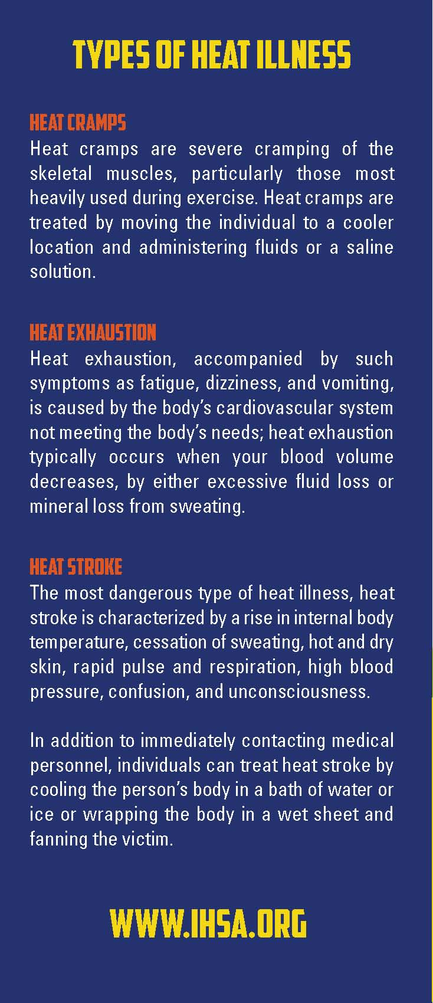

**IHSA - Managing Heat and Heat Illness**

These guidelines represent minimum standards that IHSA member schools should follow for athletic competitions. Schools with more restrictive guidelines are not expected to modify any pre-existing guidelines in order to meet this policy. These guidelines will be used by managers or their designees at all IHSA state series events when the Wet Bulb Globe Temperature (WBGT) is above 80 degrees Fahrenheit. State series tournament managers will make the decisions to suspend and resume activity in accordance with these guidelines using those devices or systems usually used at the state series venue/site.

Thirty minutes prior to the start of an activity, and again 60 minutes after the start of the activity, temperature and humidity readings will be taken at the site of the activity. Using a Wet Bulb Globe Thermometer is recommended, although a conversion to WBGT can be made from air temperature and relative humidity using chart 2. Record the readings in writing and maintain the information in files of the tournament manager and/or host school administration. Tournament managers may designate someone other than themselves to take these readings.

Use the Table 1 (see below) with an on-site WBGT reading for appropriate exercise modifications during exercising in the heat:

**Table 1**

**a.** ≤**79.9 degrees F**

i. All sports

1. Provide ample amounts of water. This means that water should always be available and athletes should be able to take in as much water as they desire.

2. Optional water breaks every 30 minutes for 10 minutes in duration. Coordinate breaks with assigned contest

officials.

3. Ice-down towels for cooling.

4. Watch/monitor athletes carefully for necessary action.

**b. 80.0-84.5 degrees F**

i. All sports

1. Provide ample amounts of water. This means that water should always be available and athletes should be

Able to take in as much water as they desire.

2. Optional water breaks every 30 minutes for 10 minutes in duration. Coordinate breaks with assigned contest

officials.

3. Provide cooling stations using methods such as ice towels.

4. Watch/monitor athletes carefully for necessary action

ii. Contact sports and activities with additional protective equipment (in addition to the above measures)

1. Helmets and other possible equipment removed while not involved in contact.

iii. Reduce time of outside activity. Consider postponing activity to later in the day.

iv. Recheck air temperature and humidity every 30 minutes to monitor for increased heat conditions or sooner if

personnel on the field suspects potential heat stress.

**c. 84.6-87.5 degrees F**

i. All sports

1. Provide ample amounts of water. This means that water should always be available and athletes should be

Able to take in as much water as they desire.

2. Schedule at least 4 separate 4:00 breaks within each hour, or a 10:00 break every 30:00 of training or

competition.

3. Coordinate breaks with assigned contest officials.

4. Have cooling stations for before, during, and after exercise/training/competition.

5. Watch/monitor athletes carefully for necessary action

6. Reduce time of outside activity as well as indoor activity if air conditioning is unavailable.

7. Consider postponing activity to later in the day or another day (with approval from IHSA Administration)

8. If practicing, maximum of 2 hours of training/practice while temperature is in this range.

ii. Contact sports and activities with additional protective equipment (in addition to the above measures)

1. Helmets and other possible equipment removed if not involved in activity or necessary for safety. If necessary

for safety, suspend activity.

iii. Recheck air temperature and humidity every 30 minutes to monitor for increased heat conditions.

**d. 87.6-89.9 degrees F**

i. All sports

1. Provide ample amounts of water. This means that water should always be available and athletes should be

Able to take in as much water as they desire.

2. Schedule at least 4 separate 4:00 breaks within each hour, or a 10:00 break every 30:00 of training or

competition.

3. Coordinate breaks with assigned contest officials.

4. Have cooling stations for before, during, and after exercise/training/competition.

5. Watch/monitor athletes carefully for necessary action

6. Reduce time of outside activity as well as indoor activity if air conditioning is unavailable.

7. Consider postponing activity to later in the day or another day (with approval from IHSA Administration)

8. If practicing, maximum of 1 hour of training/practice while temperature is in this range.

ii. Contact sports and activities with additional protective equipment (in addition to the above measures)

1. Helmets and other possible equipment removed if not involved in activity or necessary for safety. If necessary

for safety, suspend activity.

iii. Recheck air temperature and humidity every 30 minutes to monitor for increased heat conditions.

**e. 90 degrees F**

i. All sports

1. No training/competition

2. Cancel and/or postpone activity to cooler time of the day

NOTE: While most attention will be given to outdoor sports in the fall and spring, indoor venues/facilities (gymnasiums, wrestling rooms, and swimming/diving facilities) that are not air conditioned should not be neglected for the purposes of this policy. Additionally, sometimes conditions will vary for different aspects of the same competition. For example, one part of a cross-country course may be hotter or more humid than other parts. The best course of action for managers is to take a WBGT reading at the place of the most severe conditions.

**Table 2.** Estimate WBGT from ambient temperature and relative humidity assuming full sun conditions



**Cooling Methods Due to Heat Related Illness**

Exertional heat stroke (EHS) is relatively uncommon among exercise associated medical conditions, but is a frequent cause of exercise related death. The majority of evidence shows that early institution of body cooling is the most effective method of decreasing mortality in EHS. The following contains recommendations regarding the methods of body cooling, including tubs, ice bags, iced towels (towels with water that have been frozen) water, fans, and shade. The recommendations are classified as essential (foundational to the implementation of treatment, should have resources and personnel directed towards implementation), and desirable (important in maximal implementation, should have resources and personnel directed towards implementation as budget and resources allow). The recommendations are only guidelines, are not intended as a standard of care, and should not be considered as such. These guidelines should only be considered in the care of athletes who can be expected to be at risk of EHS due to the sport or the environmental situation of the activity. Sports especially at risk include football with and without equipment, soccer, and long

distance track. Other sports and activities, such as cycling, golf, baseball, tennis, track and field, and band, may also be at risk due to long duration exposure to extreme environmental conditions.

It is essential that member schools and school administrators/officials:

• Establish a written plan coordinated with local EMS for emergency treatment of EHS that includes transport to a

hospital and conduct drills in the implementation of the plan as practicable.

• Know how to assess environmental conditions and determine when extreme conditions exist.

• Identify a specific spot at the athletic facility that has shade.

• Have immediate access to ice and bags to contain ice.

• Have access to water, and provide water breaks as outlined in the IHSA Managing Heat and Humidity Policy.

• Know the most effective sites for application of ice to the body.

• Obtain and use, when environmental conditions are determined to be extreme, a tub or pool, filled with water

and ice before activity begins, to be used in body immersion for maximal cooling, and have personnel trained in this technique.

It is desirable that member schools and school administrators/officials:

• Have a certified athletic trainer (ATC) on staff, as budget and resources allow, to develop and implement these guidelines.

• Have immediate access to water.

• Provide shade breaks.

• Provide fans when environmental conditions are determined to be extreme.

• Have close access to an air conditioned room.

• Have access to and use iced towels that can be rotated to appropriate areas of the body, including the axilla, groin, and back of the neck.

**Resources**

1. *Procedure for Avoiding Heat Injury/Illness through Analysis of Heat Index and Restructuring of Activities and Recommendations*

*for Cooling Methods Due to Heat Related Illness.* Kentucky Medical Association/Kentucky High School Athletic Association.

2010.

2. Binkley HM et al. NATA Position statement: *Exertional heat illness.* J Ath Training 2002; 37: 329-343.

3. Casa DJ et al. *Survival strategy: Acute treatment of exertional heat stroke.* J Strength Conditioning Res 2006; 20: 462.

4. Armstrong LE et al. *ACSM position stand: Exertional heat illness during training and competition.* Med Sci Sports Exerc 2007;

41: 556-572.

5. *Model Policy for Managing Heat & Humidity.* Michigan High School Athletic Association. 2013.

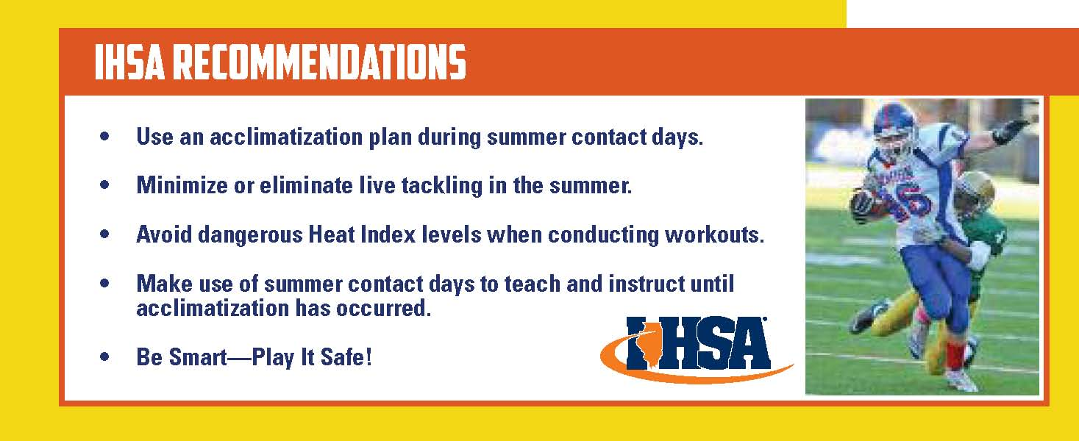

**Evacuation Plan**

Safe Areas: All personnel, athletes and spectators should be clearly informed of available safe structures or shelters in the event a thunderstorm approaches.  A safe structure is any fully enclosed building frequently used by people.  In absence of that – athletes and spectators should go to any vehicle with a hard metal roof.  Roll up the windows and do not touch the sides of the vehicle.   If no safe structure or vehicle is available, find a thick grove of small trees surrounded by taller trees or a dry ditch.  Assume a crouched position on the ground with only the balls of your feet touching the ground.  Wrap your arms around your knees and lower your head.  Minimize contact to the ground since lightning often travels through the ground.

Avoid: Tall trees or objects like light poles or flagpoles, individual trees, standing pools of water and open fields.  Also avoid being the highest object on the field.  Do not take shelter under trees.  Avoid bathrooms if another building is available, and do not use a land-line telephone.  A cellular phone or portable phone is a safe alternative if in a secure shelter or vehicle.

**Resuming Activity**

The NSSL (National Severe Storms Laboratory) recommends that everyone should wait at least 30 minutes after the last flash of lightning or sound of thunder before returning to the field or activity.

Contents © 1996-2009 Illinois High School Association. All rights reserved.

Tornado Procedures

A tornado watch is issued by the U.S. Weather Bureau for area where tornadoes may occur during the next several hours. A tornado warning means that a tornado has actually been sighted in the area or its presence has been detected by radar. Following such an issuance, persons in the path should take immediate precautions. Inside the building a series of short-steady rings will be given on the bell system. High hazard areas such as the field house and gymnasiums must be evacuated immediately and all persons moved to an inner hallway away from glass display cases and windows. Every room in the building should have posted emergency areas to move to in case of such emergencies. Never disregard the alarm. Familiarize yourself and your team with the proper response to such an emergency.

Accident Reporting <https://d300.learning.powerschool.com/rebecca.polcik/athletics/cms_page/view/36098161>

Coaches are responsible to make sure this is filled out the D300 online accident report after an injury occurs.

You will also need to follow up with the parent and athletic trainer to make sure they are aware of the injury and let them know you filled out an accident report.

**Handling Injuries**

Participation in any athletic activity presents the possibility for injuries. Although it is ultimately the goal of all of our programs to instruct student athletes in ways to avoid injury, the possibility is always there. District 300 contracts certified athletic trainers. It is their job to manage, evaluate, treat and rehabilitate all injuries of our athletes. The athletic trainers are available during most practices and home athletic events.

**Emergency Plan**

1. Depending upon the situation, the staff member will call the athletic trainer or dial 911.
2. Depending upon the situation, the athletic trainer or staff member will access the nearest AED.
3. If 911 is called, please provide:

* Information regarding your location
* Age/sex of patient
* Suspected problem
* Appropriate door, if necessary, to gain access
* Answer all questions

1. Send appropriate staff member outside to direct paramedics.
2. Athletic trainer or coach must contact parent, relative, or emergency contact person to provide transport information and hospital location.
3. Athletic trainer or coach must notify the Athletic Director, assistant Athletic Director or building Principal.
4. Incident must be documented by the athletic trainer or coach on District 300 accident report form. The report form must be turned into the athletic office within 24 hours of the accident. Injury reports are filed in the athletic training office and sent to the nurse.
5. If an adult refuses treatment, document the situation and all information you can gather – name, address, nature of injury, date, time, location, etc. This report should be returned to the athletic office.
6. All coaches are provided and expected to have in their possession an emergency information card containing emergency phone numbers and student athlete emergency cards containing emergency contact information and medical concerns or problems that particular student athlete might have.
7. If an athlete is injured or is taken to the hospital, the coach/coaches and athletic trainer should

follow up with a phone call or visit to the parents and athlete as soon as possible.

**Dundee Crown High School**

**Sports Medicine Emergency Action Plan**

**Introduction**

Emergency situations may arise at any time during athletic events. Expedient action must be taken in order to provide the best possible care to the sport participant of emergency and/or life threatening conditions. The development and implementation of an emergency plan will help ensure that the best care will be provided.

As emergencies may occur at any time and during any activity, the athletic association must be prepared. Athletic organizations have a duty to develop an emergency plan that may be implemented immediately when necessary and to provide appropriate standards of emergency care to all sports participants. As athletic injuries may occur at any time and during any activity, the sports medicine team must be prepared. The preparation involves formulation of an emergency plan, proper coverage of events, maintenance of appropriate emergency equipment and supplies, utilization of appropriate emergency medical personnel, and continuing education in the area of emergency medicine and planning. Hopefully, through careful pre-participation, physical screenings, adequate medical coverage, safe practice and training techniques, and other safety avenues, some potential emergencies may be averted. However, accidents and injuries are inherent with sports participation, and proper preparation on the part of the sports medicine team should enable each emergency situation to be managed appropriately. Keep in mind that the ill or injured person may not always be a student-athlete. Emergency situations can arise involving parents, spectators, coaches, and officials.

**Emergency Personnel**

NATA Certified Athletic Trainer will be on site during all practices and competition. Team Physician and Paramedics will be at varsity home football games. Emergency Medical System (EMS) is also available by calling 9-911. Athletic Training staff should be made aware of any emergency within the athletic department.

**Emergency Communication**

Cell phones will be on site during all practices and games. When using campus phones, you must dial 9 to exit the building and then the number. Coaches and Administration should have cell phones on them at all times. If you dial 911, do not hang up. Please wait for someone to answer.

**Emergency Equipment**

Supplies such as Automatic External Defibrillator (AED) and first-aid kits will be located with the home team and certified athletic trainer. State law indicates and AED must be within 300 feet of athletic competition.

**Fall Season**

**1st** AED will be located on the east side of the building with freshman football practice

**2nd** AED will be located at the varsity football field. **During soccer games and when football is not present, AED will be located next to storage shed between the soccer fields.**

**3rd** AED is located outside the female coaches locker room (next to athletic training room)

**Winter Season**

**1st & 2nd** AEDs are located in the athletic training room

**3rd** AED is located outside the female coaches locker room (next to athletic training room)

**Spring Season**

**1st** AED will be located behind the varsity baseball home dugout during all practices. If

only Softball has a game, AED will be in Varsity/JV field home dugout.

**2nd** AED will be on the Track with the water coolers. If there is a soccer game, or track is

not present, AED will be located next to storage shed between the soccer fields.

**3rd** AED is located outside the female coaches locker room ( next to athletic training room)

*COACHES: IF YOU ARE THE LAST TEAM TO PRACTICE OUTSIDE, IT IS YOUR RESPONSIBILITY TO MAKE SURE THE AED IS RETURNED TO THE ATHLETIC TRAINING ROOM.*

**What is my role?**

**Coaches**

* Call 911 and have someone alert ATC immediately
* Keep other players off the field and a safe distance away from the injured athlete
* Call athlete's emergency contact, bring parent to sideline if he/she is present
* Accompany injured athlete to Emergency Room if parent/ guardian is not present

**Athletic Director**

* Assist coaching staff
* Alert Security of EMS activation

**Athletic Trainers**

* Attend to injured athlete
* Designate person to call 911
* Designate athletic training student or coach to bring equipment to field
* Complete accident report

**Team Physician**

* If present, attend to injured athlete

**Athletic Training Students**

* Assist ATC's by bringing equipment to field
* Assist Security personnel in directing EMS to injury site

**Security**

* Maintain crowd control to allow for quick and easy entrance of EMS personnel
* Meet EMS personnel and direct them to venue/injury site

**Sample EMS Call**

My name is ____(your name)___ and I am calling from the __(Varsity/ Lower Level)___ baseball fields at Dundee Crown HS. We have ___(number of individuals injured)____ athletes(s) who need immediate medical attention. The athlete is ___(condition of athlete)___. Our athletic trainer is on the scene and has provided ___(first aid care)___. To reach the Varsity field, please enter the southeast parking lot and take the path east of the Tennis courts towards the storage shed by the softball field.

**Emergency Contact & Insurance Information**

If the victim is a student-athlete, it is suggested that a Dundee Crown High School representative accompany the athlete to the hospital, unless parents are present. This should be a coach or member of school administration. This individual is responsible for contacting the athlete's family, providing directions to the hospital, handling patient registration, and providing updates to the Athletic Trainer as the game or practice continues. Team member's emergency contact cards should be with coaches at all times. All injured athletes will be transported to Sherman Hospital 1425 N Randall Rd., Elgin.

**Important Phone Numbers**

Police-Fire-EMS 9-911

IL Poison Control 1-800-222-1222

Non-Emergency Dispatch 1-847-428-8784

Head Athletic Trainer: Brenna Risch (224) 484-5286 (office) (630) 774-9000 (cell)

Athletic Director: Steve Gertz (224) 484-5023 (office); (847) 471-1225 (cell)

Team Physician: Dr. Josh Alpert (847) 931-5300 (office) (773) 454-1203 (cell)

**Emergency Plan: Football Stadium, Track, & Soccer Field Venue**

**Emergency Personnel:**

Certified Athletic Trainer and student athletic trainer(s) will be on site for practice and competition. (Ambulance on site for Sophomore and Varsity Football game)

**Emergency Communication:**

Certified Athletic Trainer carries cell phone (Brenna Risch, 630-774-9000); additional fixed telephone lines accessible in school.

**Emergency Equipment:**

Supplies kept with ATC (AED, Trauma kit, Splint kit)

**Roles of First Responders**

1. Immediate care of injured or ill student-athlete
2. Activation of emergency medical system (EMS) 9-911 call (provide name, address, telephone number, number of individuals injured, condition of injured, first aid treatment, specific directions, other information as requested)
3. Emergency equipment retrieval

**Direction of EMS to scene**

* Security personnel will open appropriate gates
* Designate individual to “flag down” EMS and direct to scene
* School administrators and security will control the scene: limit scene to first aid providers and move bystanders away from area

**Venue Directions**

* Stadium is located at the bottom of the hill northwest of the school
* Enter school parking lot at Kings Road
* Ambulance can drive through open gate onto the track/field
* Security or administration needs to inform EMS to fold in their mirrors to be able to fit through the gates. For injuries at the soccer fields, EMS should drive around the track to the northeast corner of the stadium. Equipment can then be brought through the gates. (see attachment A)

**Emergency Plan: Tennis Courts, Softball, & Baseball Fields**

**Emergency Personnel**

Certified Athletic Trainer and student athletic trainer(s) will be on site for practice and competition.

**Emergency Communication**

Certified Athletic Trainer carries cell phone (Brenna Risch, 630-774-9000) additional fixed telephone lines accessible in school.

**Emergency Equipment**

Supplies kept with ATC (AED, Trauma kit, Splint kit)

**Roles of First Responders**

1. Immediate care of injured or ill student-athlete
2. Activation of emergency medical system (EMS) 9-911 call (provide name, address, telephone number, number of individuals injured, condition of injured, first aid treatment, specific directions, other information as requested).
3. Emergency equipment retrieval

**Direction of EMS to scene**

* Security personnel will open appropriate gates
* Designate individual to “flag down” EMS and direct to scene
* School administrators and security will control the scene: limit scene to first aid providers and move bystanders away from area.

**Venue Direction**

* Baseball & Softball Fields are located on the East side of the school.
* Ambulance should enter off Kings Road/ Amarillo near the Junior parking lot. Security should meet ambulance at Gate next to parking lot to allow them to drive on path up to the varsity softball field.
* For Freshman Softball, Ambulance should drive to parking lot just east of the school and pull up to the softball field near Perry Elementary.
* For Tennis, the ambulance should pull up to the circle drive next to Tennis courts. (see attachment A)

**Emergency Plan: Field House & Main Gym**

**Emergency Personnel:**

Certified Athletic Trainer and student athletic trainer(s) will be on site for practice and competition.

**Emergency Communication:**

Certified Athletic Trainer carries cell phone (Brenna Risch, 630-774-9000) additional fixed telephone lines accessible in school.

**Emergency Equipment**:

Supplies kept with ATC (AED, Trauma kit, Splint kit)

**Roles of First Responders**

1. Immediate care of injured or ill student-athlete
2. Activation of emergency medical system (EMS) 9-911 call (provide name, address, telephone number, number of individuals injured, condition of injured, first aid treatment, specific directions, other information as requested)
3. Emergency equipment retrieval

**Direction of EMS to scene**

* Security personnel will open appropriate gates
* Designate individual to “flag down” EMS and direct to scene
* School administrators and security will control the scene: limit scene to first aid providers and move bystanders away from area

**Venue Directions**

* Main Gym & Field House are located on the East side of the school.
* Ambulance should enter off Kings Road/Amarillo and proceed to the circle drive by Athletic Doors.
* Security should meet ambulance at athletic doors for Field House access.
* For situations in the main gym, ambulance should pull up to door #11 on the east side of the building.
* Security will need to meet EMS at this door. (see attachment A)

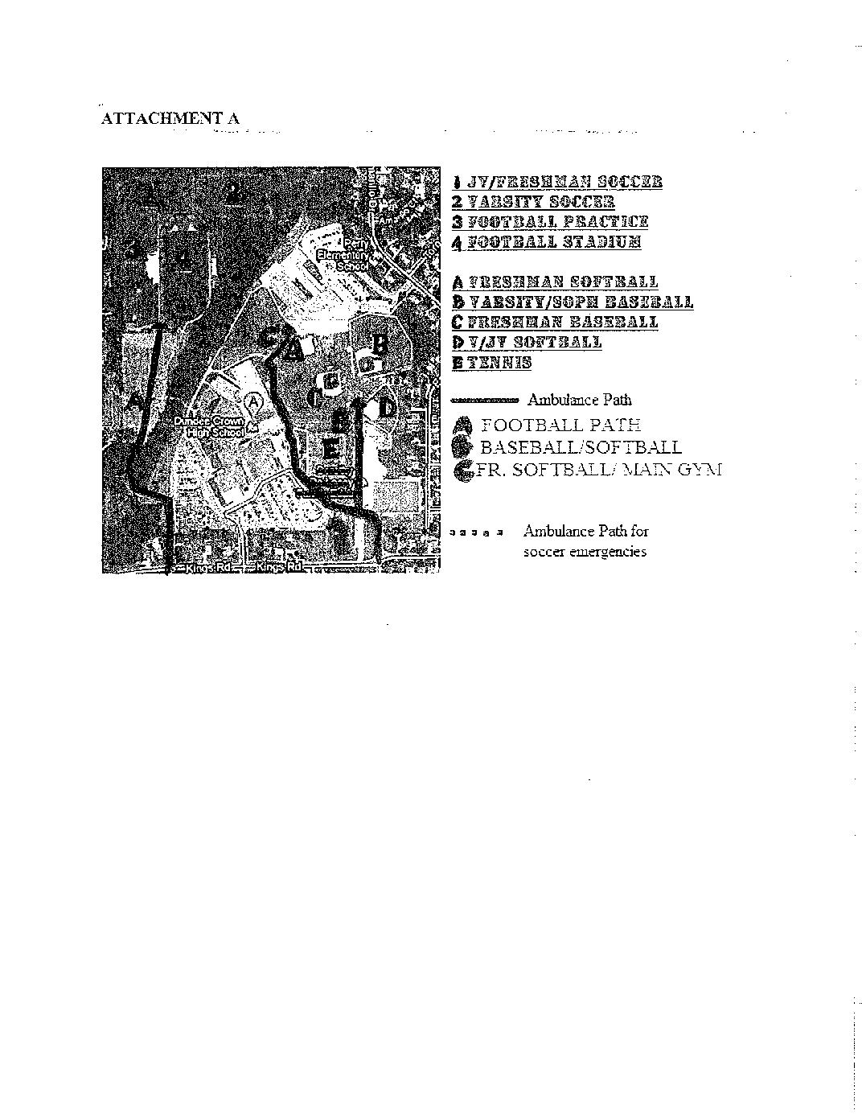

**ATHLETIC DEPARTMENT**



**INCLEMENT WEATHER PLAN FOR FOOTBALL GAME**

**Note: Everyone should monitor the weather from their location and radio to the Principal/AD any lightning strikes or concerns with the weather. We will use the “30-30 RULE” and** **IHSA Severe Weather Safety Guidelines.**

**Announcer:** Make an announcement to clear the stadium. Spectators can either go to their cars or move to the SCHOOL through DOOR 1 (MAIN ENTRANCE) or DOOR 2 (ENTRANCE BY BOWL STAIRS).

**Administrator (TBA):** Take visiting team and coaches to D-C Gym through Girls Locker Room, DOOR 9. Take team through the stairs located behind the visitor bleachers and proceed to the school. Enter through the Locker Room Doors. The Administrator will stay with the visiting team to keep them updated on changes.

**Principal:** Take officials to the Storage Shed located behind the bathrooms. The Principal will stay with the officials to keep them updated on changes.

**Administrator (TBA):** Take home team to the field house locker room. Enter through DOOR 10. The Dean will stay with the home team to keep them updated on changes.

**AD (Steve Gertz):** Verify the stadium has been cleared. Identify a location to monitor weather. Communicate updates to supervisors and workers via walkie-talkies.

*Depending on the severity of the weather, a location will be determined to meet with school AD’s, Head Coaches, and officials to decide on how events will proceed.*

**Administrators & Deans -** Check stadium and encourage fans to move to either the school or their car for shelter. Once in the gym, pull out both sides of bleachers and monitor the gym.

**Workers (ticket takers, supervisors, security, etc.):** Help clear stadium/stands/bathrooms areas where fans may hide. Help monitor gyms/hallways etc. once inside.

**Game Schedules & Reschedules:**

* If the Varsity game was started and play was suspended, the game can be restarted up to 10:00 pm.
* If the Varsity game has not yet started, the game can be started up to 9:30 pm.
* If either the F/S and/or Varsity game cannot be played on Friday, the game time will be announced based on Saturday field usage, availability of officials, and availability of workers.

**Tickets:** If the game is suspended prior to the start of the Varsity game and rescheduled for another day, fans that paid will be given tickets for the next day’s game. If the game is suspended once the Varsity game has started, no admission will be charged.

**Athletic Trainer Information**

The Sports Medicine/Athletic Training Program has been established to look out for the well-being of Dundee Crown High School student-athletes.

All decisions will be made with the student-athletes’ best interest in mind. Posted Training Room Rules are to be followed at all times.

Athletes are not allowed in the training room unless they are directly supervised by the athletic trainer, student athletic trainer, or coach. Please do not leave athletes unsupervised.

Respect is to be given to the entire Sports Medicine/Athletic Training staff. This includes respecting the student athletic trainers as well. Unacceptable behavior will be brought to the attention of administration.

All equipment (i.e. coolers, water bottles, kits, etc.) is the property of the Dundee Crown Sports Medicine/Athletic Training Program. Disrespect/abuse of any equipment will not be tolerated!

All traveling teams will be required to have a medical kit. These kits are provided for all teams in the athletic training room. All kits are fully stocked at the beginning of each season. If supplies are needed, please notify one of the members of the Sports Medicine/Athletic Training staff.

All injuries must be reported to the athletic trainer either the day that they happen or the next day of school. An athletic injury report must be filled out for each of your team’s injuries. Please let the athletic trainer know if an athlete has been seen by a physician.

Any athlete who has sustained a significant injury (one with loss of practice/game time) must have clearance to return to his/her activity from the athletic trainer who receives this clearance from their physician. NO EXCEPTIONS!

No reductions of fractures or dislocations will take place on the grounds of Community High School District 300. Only a licensed physician may perform such procedures in the State of Illinois.

Any notes regarding medical information or playing status must be given to the athletic trainer upon receipt. Any athlete that has seen a physician (or has been referred to see a physician) for any condition, must have a written or verbal clearance to the athletic trainer prior to any return to activity (including practice). The athletic trainer’s opinion cannot override any recommendation made by a physician.

*Ex: When a doctor has an athlete out for 2 weeks, they are out for 2 weeks unless further documentation or follow-up has been made.*

Information regarding an athlete’s health care is considered confidential and should not be shared with anyone, including other parents, athletes, coaches, or media.

As per the IHSA, physicals must be performed by a Licensed Medical Doctor (MD), a Physician’s Assistant (PA), or an Advanced Nurse Practitioner.

Application of taping/bracing/wrapping will only be considered following an evaluation by the athletic trainer.

Keys to the athletic training room are provided to all coaches prior to their respective season and should never be given to athletes. These keys will open the outside door of the athletic training room only. When leaving the training room, please make sure the doors are locked unless a member of the athletic training staff is present.

**Remember…do not leave athletes unsupervised in the athletic training room.**

Water and ice coolers are provided for home *AND* visiting teams participating here at the high school. The Sports Medicine/Athletic Training Staff will bring these coolers to your home fields. Sleeves of cups will only be provided to teams that do not get their own water bottles. Coolers must be brought in by student-athletes or coaches after practices and events.

In some cases, athletes will be given their own water bottle at the start of their season. It is their responsibility to bring this bottle to each practice/event. Please delegate athletes to return both the home *AND* visitors coolers back to the training room. Coolers need to be rinsed and cleaned out. (especially if Gatorade is used) Please treat them as you would treat your own equipment.

Please keep the training room clean. Wipe off the counters and take care of any mess that you may have made.

Rules regarding visitation to the athletic training room after school:

* Order of sign-in is critical to the visitation by the athletic trainer
* First aid can and will be performed by student athletic trainers
* All first aid/taping/bracing will be performed prior to any new injury evaluations

Official order of treatment:

* AWAY Event Athletes
  + Based on bus departure times
  + Based on order of sign-in on Treatment Log
* HOME Event Athletes
  + Based on order of sign-in on Treatment Log
* PRACTICE Athletes
  + Based on order of sign-in on Treatment Log
* Injury Evaluations
  + Based on order of sign-in on Treatment Log

**Summer Camp Procedures**

The purpose of summer camps is to introduce potential athletes to your program and to attempt to develop their skills. Coaches should develop, and turn in to the Athletic Director, a complete expense and revenue report for their respective camps. All scheduling for summer camps must be done in accord with coaches of other sports and the Athletic Department to try to avoid conflicts of facilities and athletes. Registration is to be completed in conjunction with the park district.



**Athletic Department Budgeting**

There are three primary athletic program funding sources:

The Community School District 300 School Board Approved Budget

This is supported by taxpayers dollars, state and federal monies. Once the annual athletic department budget is approved by the Board of Education the monies become available by line item as determined by the Athletic Director, school and district administration.

Student Activity Funds

These funds are owned, operated and managed by organizations, clubs, or associations (groups) within the student body under the guidance and direction of one or more faculty or staff members for educational, recreational, or cultural purposes. A team, i.e., boys’ basketball, may establish an activity account, engage in fundraising activities if approved, and use the monies collected provided the organization observes the strict guidelines of the Student Activities Manual.

Athletic Booster Club Funds

Parents who make up the Athletic Booster Clubs actively fundraise to support all district athletic sport programs. Head coaches are encouraged to complete Booster Club request form for supplies, equipment, or team initiatives that are not supported by the school’s regular athletic budget. Upon completion, the form must be submitted to the Athletic Director. He will make a determination if the requisition is to be presented at the Booster Club’s monthly meeting. If approved by the Athletic Director these presentations would be made by the coaching staff to the Booster Club Board.

The annual athletic budget shall be submitted by the Athletic Director to the Business manager each year. Each coach must submit a copy of his or her expected budget to the Athletic Director.

Areas that should be considered when preparing a budget

* Equipment and supplies (This would include balls, uniforms, repairs,

etc.).

* Contractual services (rental fees) should be discussed and approved by the

Athletic Director.

* Advance professional travel to clinics and meetings should also be discussed

and approved by the Athletic Director.

Guidelines for Budgeting

* Budget for “real needs”.
* The head coach should spend time talking to his/her staff and planning for future needs.
* Budgets will fluctuate from year to year as there are certain large price items and uniforms that do not always have to be purchased each year.
* The head coach should always be responsible to purchase quality goods at the best possible prices. This will be done by shopping around.
* Each head coach will discuss his/her budget with the Athletic Director individually.

**Activity Accounts**

Please refer to the Student Activity Procedure Manual that all head coaches with activity accounts receive.

8th Grade Orientation Night

The incoming 8th Grade Orientation Activity Fair for the incoming class is typically held each year. Coaches are expected to take part in this valuable experience to promote their program with incoming students interested in their sport. Coaches should have sign-up forms available for incoming students, so that they can mail them summer camp and other pertinent information as it becomes available. Coaches will need to fill out the proper paperwork with the Athletic Director/Activities Director in order to have the space and proper equipment available on the night of the fair.

**Athletic Participation Requirements**

Any student interested in playing a sport must be cleared prior to the start of the season. Forms need to be completed and turned into the Athletic office along with payment by the dates specified for each sport. **Incomplete paperwork will not be accepted**. Paperwork turned in late may take as long as 5 school days to be processed.

**Current Physical**

All athletes participatingin any athletic activity MUST have acurrent physical on file with the athletic department. Physicals used for sports are current for 395 days. Incoming freshmen must have a regular physical which has interscholastic sports checked. A copy of the physical must be turned in.

**Register – (online at https://dundeecrown.8to18.com)**

Both parent/guardian & athlete must consent to these forms. This form includes background information,

Emergency Card, Steroid Testing, Concussion Information and Consent forms.

**Academics**

Athletes must pass at least 5 classes on a weekly basis and at semester to be eligible. If an athlete does not pass

5 classes at the end of first semester, they will not be eligible to for the winter and spring sports. If an athlete

does not pass 5 classes at the end of second semester, they will not be eligible for the fall and winter season.

**Athletic Fee**

All athletes must pay the athletic fee before they may participate. Athletes must pay a $150 participation fee per sport with a high school maximum of $300 per athlete and $600 per family per school year. Athletes whose families have been qualified for the Free/Reduced Lunch Program will have their fees waived.

***When all of the above criteria have been met you athlete will be cleared and a copy of his/her Registration Form will be given to the coach.***

**Note:** *Each coach is responsible for knowing the status of the required paperwork for each of their athletes.*

**Pre-Season Preparation**

**Equipment Preparation**

The coaching staff is responsible for the preparation and organization of all equipment needed throughout the season. If tools are needed to assemble items, cameras are needed for videotaping, or trucks are needed to transport equipment, etc., contact the Athletic Director and arrangements will be made. Be sure to allow ample time when requesting anything needed for your program.

**Equipment Handout**

When handing out the equipment to your athletes, be sure to have an equipment form that is appropriate for your sport. Each item should have a replacement cost next to it in case items are lost.

**Purchases and Inventory**

When new items are received in the athletic office, coaches will be notified of their arrival. The coaches are expected to remove the items from the athletic office at their earliest convenience. These items should then be inventoried by the coach and placed in the appropriate area. Be sure to mark all new equipment and be sure to use a permanent marker. Coaches must inform the Athletic Director that all items ordered have been received, and are in good condition.

Inventory Google Doc - <https://docs.google.com/forms/d/1YX-b6kJhsXHUVcwB8PglbHp3anqrqDuZBNyN0jJbCwU/viewform?edit_requested=true>

**Pre-Season Meetings**

All programs must have a preseason meeting with parents and athletes. Athletic paperwork will be available, if necessary. All coaches must dress in a nice pair of shorts, pants and a coaching shirt for this event displaying unity and a sense of team/school pride.

Coaches should not collect the paperwork from their athletes; but instead should instruct them to return it directly to the Athletic Office prior to the start of practice. Coaches will receive a printout as to which athletes are eligible and ineligible because of missing items.

**Note:** *IHSA By-Laws limit members schools to (1) one pre-season meeting for the purpose of distributing information, and going over procedures and required paperwork.*

**

Pre-Season Parent Meetings - Suggested Topics

# Introduce Athletic Booster Representative – encourage membership

# Introduction of Coaching Staff

* Contact numbers – phone, e-mail addresses
  + Reasons to contact – general questions, absences, injuries, emergency situations

# Game & Practice Schedules

* + Subject to change due to weather, facilities, opposing school conflict – check the D-C web
  + Attendance expectations on Saturdays, holidays, and non-attendance days
* Explain your coaching philosophy – playing time, cuts, winning/losing, value of participation, off-season expectations – private club involvement
* Location of away contests – or check the web site
* Transportation to and from contests/practices
  + Bus conduct & expectations (travel to and from as a team) exceptions in special situations
  + Parent pick up on the east side of bldg.
  + Driving to off**-**site locations (forms)
* Uniform and Equipment Care – fine slips issued for lost items
* Lock lockers, don’t carry large sums of money, valuables to school
* Academic Eligibility – weekly check (must pass a minimum of 5 classes), must have passed at least 4 classes previous semester (for Sophs, Jr’s, Sr’s & 2nd semester frosh)
* Extracurricular Code of Conduct – thoroughly go over this!
  + Ask for questions – do a good job reviewing
* Procedure when athletes quit or are removed from a team – **Contact the parents immediately**

**Distribute the information on Athletic Program/Parent Expectations**

* Be supportive, don’t coach your child (or others)
* Expressions of frustration/disappointment by adults are contagious
* Don’t demean the opponents (competitors or coaches)
* Cheer when our team does something well, not when the opponent fails
* Our climate/atmosphere is not the same as a collegiate or professional event – act accordingly, set a good example for others.

**NCAA Clearinghouse Basics**

## FAQs about the NCAA Initial-Eligibility Clearinghouse

Student athletes must register with the NCAA Initial-Eligibility Clearinghouse to be eligible to play NCAA Division I or Division II sports in college. (Athletes playing in NCAA Division III do not have to register.)

### What is the NCAA Initial-Eligibility Clearinghouse?

### The NCAA Initial-Eligibility Clearinghouse is the organization that determines whether prospective college athletes are eligible to play sports at NCAA Division I or Division II institutions. It does this by reviewing the student athlete's academic record, SAT or ACT scores, and amateur status to ensure conformity with NCAA rules.

### What are NCAA Divisions I, II, and III?

The NCAA is the governing body of many intercollegiate sports. Each college and university regulated by the NCAA has established rules on eligibility, recruiting, and financial aid, and falls into one of the three membership divisions (Divisions I, II, and III). Divisions are based on school size and the scope of their athletic programs and scholarships.

### When should students register with the clearinghouse?

The NCAA recommends that student athletes register with the clearinghouse at the **beginning of their junior year** in high school, but many students register after their junior year. There is no registration deadline, but students must be cleared by the clearinghouse before they receive athletic scholarships or compete at a Division I or Division II institution.

### How do students register with the clearinghouse?

Students can register online at the [NCAA Clearinghouse website](https://www.ncaaclearinghouse.net/NCAA/common/index.html). They will have to enter personal information, answer questions about their athletic participation, and pay a registration fee. The website will then prompt them to have their high school transcript and ACT or SAT scores sent to the clearinghouse.

### Can students have the registration fee waived?

Students who have received a waiver for the SAT or ACT are eligible for a waiver of the clearinghouse registration fee. The student's counselor must submit confirmation of the student's test fee waiver. Go to the NCAA Clearinghouse's [High School Administration page](https://www.ncaaclearinghouse.net/NCAA/hs/index_hs.html) for more information.

### What records does the clearinghouse require?

Students should arrange to have you send their high school transcript to the clearinghouse as soon as they have completed at least six semesters of high school. The transcript must be mailed directly from their high school. They must also arrange to have their ACT or SAT test scores reported directly by the testing company to the clearinghouse. Students can arrange this when they register for the ACT or SAT.

**You are responsible for sending in students' final transcripts and** **proof of graduation** at the end of their senior year.

How often can students update their athletics participation information?

Students can update the information on the athletics participation section online as often as they want (and should update it regularly), up to the time when they request a final certification of their status. At that point (usually three to four months before enrolling in college), students must finalize their information.

### What are the NCAA academic eligibility requirements?

To play sports at an NCAA Division I or Division II institution, the student must:

* Complete a certain number of high school core courses (defined below)
* Earn a certain minimum grade point average in these core courses
* Earn a certain minimum score on the SAT or ACT (for Division I, this is scaled according to the student's core-course GPA)
* Graduate from high school

For more information, see the NCAA's *Guide for the College-Bound Student-Athlete*, available at the [Publications section](http://www.ncaapublications.com) of the [NCAA website](http://www.ncaa.org/wps/portal).

### What are core courses?

"Core courses" is the name that the NCAA gives to high school courses that meet certain academic criteria specified by the association. Students must complete a certain number of core courses for NCAA Division I and II eligibility.

### How are high school courses classified as core courses?

All participating high schools submit lists of the courses that they offer that meet NCAA core-course criteria. If approved, the courses are added to a database that the NCAA Initial-Eligibility Clearinghouse maintains. You can check this database, or [List of Approved Core Courses](https://www.ncaaclearinghouse.net/NCAA/common/f3_48h.jsp), to see whether your student athletes are enrolled in courses that will count toward NCAA eligibility.

It will most likely be your job as counselor to provide the NCAA with the list of your school's core courses, and to update this list annually. The NCAA may ask for more information before approving a core course.

### What are the NCAA amateurism eligibility requirements?

To play sports at an NCAA Division I or Division II institution, the student-athlete must follow NCAA amateurism rules as regards receiving a salary or prize money for athletic participation, playing with a professional team, and other areas. For more information, see the *Guide for the College-Bound Student-Athlete* linked above.

### Keep in mind

**The best way for students to prepare for a future in college athletics is to complete the approved core courses and earn appropriate grades in them.** Indeed, more students fail to qualify to play NCAA sports because of lack of appropriate course work than for low test scores.

Make sure your athletes are enrolled in the courses on your high school's core-course list, and also know the eligibility requirements on the [NCAA Clearinghouse website](https://www.ncaaclearinghouse.net/NCAA/general/index_general.html). Then make sure your athletes are taking the necessary courses, earning the necessary grades, and doing anything else they must to stay on track for NCAA eligibility.

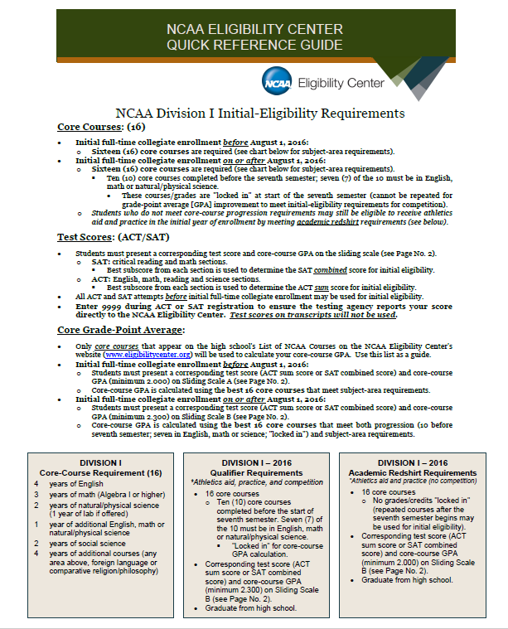

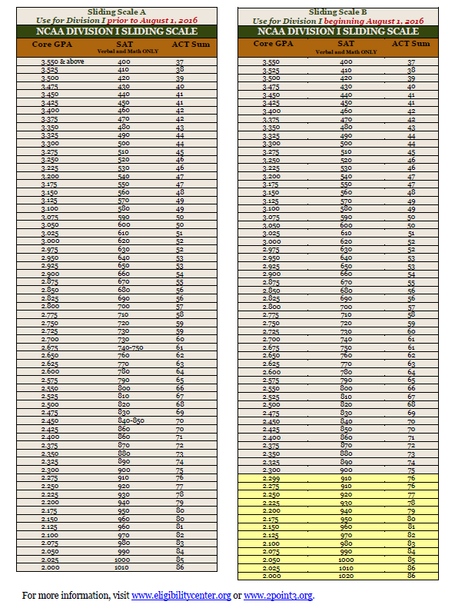

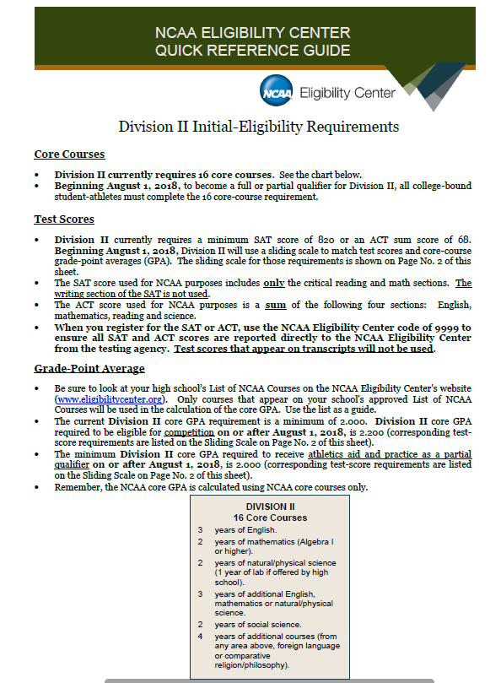

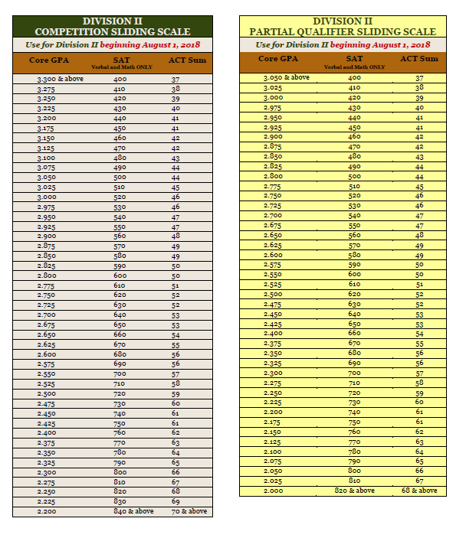

For more information, visit the NCAA Eligibility Center website at www.eligibilitycenter.org.

**Fundraising**

Head coaches must refer to their Student Activities Procedure Manuals that were distributed for these details. Please read these details before any fundraising project begins.

Here is a link for the forms - <https://d300.learning.powerschool.com/rebecca.polcik/athletics/cms_page/view/36011242>

**Tryouts and Tryout Deadlines**

All tryouts are announced well in advance of the start of the athletic season. The coach must explain his/her procedures for tryouts and his/her criteria for making the team. If an athlete does not make the team, the coach is expected to discuss the reason(s) with the student and suggest areas of improvement for the next season. Head Coaches must include a form documenting on what criteria athletes will be evaluated.

If possible, we would like to keep all athletes that fulfill the requirements on all teams. However, because of the number of coaches in a sport in relation to the number of athletes, it may be necessary to cut athletes due to supervision and safety reasons. When choosing your teams, please consider your ability to provide the athletes selected with the opportunity to participate in the events or games.

The names of those athletes cut should be immediately given to the Athletic Office and to other in-season coaches that do not cut or have low numbers. All coaches need to help one another.

Athletes that Withdraw or Are Cut from a Team

Names of athletes who withdraw or are dismissed from a team should be given to the Athletic Office so that they can be removed from the eligibility list, and reimbursed their athletic fee, if applicable. The coach is responsible for calling the parents/guardians as soon as possible, and notifying them of the circumstances surrounding the dismissal of their son or daughter from the team.

**In-Season Policies and Procedures**

#### Communication

#### In any organization, communication is the key to success. PLEASE communicate any information pertaining to your sport or the athletic department as a whole to the Athletic Director before discussing it with anyone else. Please give the athletic office copies of any mailers or other items regarding your program. Often times we receive phone calls from parents/guardians regarding these things, and we do not know about it. Please follow the recommended lines of communication below to help this department run smoothly.

**District 300 Athletic Department Communication Flow Chart**

**Roster Changes, Dismissals, Level Changes or Withdrawals**

Please notify the athletic office at any time throughout the season if there are athletes who withdraw or are dismissed from the team, players who move to a different level or roster changes of any kind. You must fill out a drop form to be sent to parents and filed with the Athletic Office. (see forms)

**Reporting of Scores**

A coach shall enter his/her scores by 9:00 a.m. of the day following their contest in 8to18 and must fax or email scores to the newspapers. The easiest way to do this is simply to come into the Athletic Office following your event and fax your results to all newspapers via the Athletic Department fax machine. Please see Athletic Director for instructions on entering scores into 8to18 program.

**Scholastic Eligibility**

**Weekly Eligibility**

All athletes must be passing at least five (5) courses weekly. If not, the student athlete will not be allowed to participate in contests the following week (Sunday through Saturday). The athlete will attend all practices and contests. The student-athlete will not be in full uniform for the games and will not be allowed to participate in any pre-game activity.

***It is recommended that the coaches not allow the athlete to attend practices if the athlete is ineligible for 2 or 3 consecutive weeks.

On Wednesday or Thursday, the coaches will receive a report of students who are either ineligible or in danger of becoming ineligible. Coaches are expected to talk individually with each athlete and encourage them to get the needed help to improve their grades.

**Semester Eligibility**

All athletes must be passing at least five (5) courses by semester grade to be eligible for the next semester. Exceptions are incoming freshmen – they are eligible to participate the first semester. After first semester grades are issued, they must have passed five (5) courses to be eligible. If a student athlete failed to pass five (5) courses, he/she will be declared ineligible for the next semester.

**Transfers and Foreign Exchange Athlete Eligibility**

Any student that transfers from another school to D300 or foreign exchange student/athlete must be approved by the IHSA. You must see the Athletic Director and special IHSA forms must be filled out and approved by the IHSA **BEFORE** a transfer or foreign exchange student/athlete may participate.

**Absences and Participation**

**Excused Absences**

Excused absences are defined in the Student/Parent Handbook. A note from a parent/doctor or a phone call to the coach should accompany any absences, such as extreme sudden illness, death in the immediate family, or other extreme circumstances.

**Unexcused Absences**

Unexcused absences are unacceptable, and students will suffer the consequences outlined in his/her coaches’ rules/expectations.

**Note:** *If an athlete is absent from your practice and the coach was not notified, it is advisable for the coach to call the home to find out what happened and show concern for the athlete’s well-being.*

**Daily Attendance and Participation**

If an athlete is absent from the entire or part of the school day, he or she may NOT participate in the practice or game/event on that day. The Dean of Students or building administrator makes all judgments on the validity of an absence!

**Note:** *It is the coach’s responsibility to look at the absentee bulletin at the end of the day to make him/her aware of the athletes who are absent.*

**Friday Absence - Saturday Play**

If an athlete is absent on the Friday preceding a Saturday event, the athlete will be allowed to participate on Saturday.

**Rescheduled Events**

If games/contests are rescheduled due to inclement weather, building usage conflicts, or any other reason, you will be notified by the athletic office.

**Travel to and from Athletic Events**

Each head coach is responsible for setting up his or her bus schedule for games, events or practices. The Athletic Director’s secretary should receive this information well in advance of the first contest or practice and she will in turn relay this information to the transportation department. A weekly bus schedule will be emailed to coaches each week for the week to follow. Please take time to check it over before the week begins. In the case of a schedule change, a notice will be placed in your mailbox and the bus time will be changed accordingly.

In the event that a District 300 team or individual qualifies for State competition, the following are some guidelines to be followed:

1. Fill out the proper “PD and Travel Pre-Approval” forms and submit them to the Principal.
2. Request a bus or van.
3. Request travel money or P-Card in advance through the Athletic Director for your trip.
4. Have athletes fill out necessary district approved forms.
5. Work with the Athletic Director and Business Office to make necessary lodging arrangements.
6. Provide the athletic office with an approved itinerary. (see sample on page under forms)
7. Provide the parents and athletes with an approved itinerary.
8. Out of state in-season trips must be approved by the Board of Education in advance. The following items must be submitted to the Athletic Director prior to board approval:
9. Proposal
10. Itinerary
11. Field Trip Request Form – Copies are available on SharePoint in the Student Activities folder
12. Transportation Request Form – See Transportation SharePoint link for forms and procedures
13. Staff leave forms for all staff members attending.

**Activity Bus and Suburban**

Coaches with smaller teams and groups are encouraged to use the D300 Activity Buses, Vans or Suburban.

Activity Bus - 14 passengers plus the driver

Vans and Suburban – 7 passengers plus the driver

If interested,

* You must submit your driver’s license at the beginning of the year to Becky in the athletic office for your MVR (Motor Vehicle Report).
* Notify the Athletic Office that you are interested in being trained to drive the Activity bus (only need to do this once).
* Transportation will email you the required training materials which you must review and acknowledge.
* A Behind the Wheel road test will need to be scheduled.
* Once you have successfully completed the classroom and BTW, you are set to drive the Activity Bus.

***All D300 and Durham vehicles have GPS (monitors speed) and camera’s. It is essential that all D300 rules and expectations are followed at all times.***

SAMPLE OVERNIGHT TRIP ITINERARY

Tennis

Bloomington Itinerary

Dear Parents and Players:

On Friday, September 10th and Saturday, September 11th, ten team members and I will attend the Bloomington Purple Invitational. Hopefully, this letter will answer any questions concerning the trip.

Itinerary for Friday, September 10

3:30-6:00 – Activity bus leaves D-C at 3:30 and arrives in Bloomington

6:00-6:30 – Check-in at Hampton Inn in Bloomington

6:30-7:30 – Dinner

7:30-9:30 – Movie or Bowling (one of these days traffic may allow for this)

9:30-10:00 – Return to Hampton Inn, team meeting, bed check, lights out

10:00-6:00 – SLEEP

Itinerary for Saturday, September 11

6:00-6:45 –Rise and shine, pack, load gear on bus

6:45-7:30 –Breakfast compliments of Hampton

7:30-7:45 –travel to Bloomington H.S.

7:45-8:15 –warm-up for tournament

8:15-8:30 –meet for specific sites, travel to sites

8:30-4:00? –I honestly do not know when matches will end; phone calls made to parents when all matches are completed stating our ETA to D-C

4:00-7:00 –late lunch/early dinner and travel home

7:00 –10:00pm arrive at D-C

What the school provides: What you should bring:

1. Bus to and from contest 1. tennis racquet(s)

2. Hotel stay at Hampton Inn 2. water container

3. Dinner for Friday night 3. towel (not the hotel’s)

4. Breakfast for Saturday morning 4. shoes

5. Lunch for Saturday afternoon 5. two shirts

6. a pair of shorts/skirt with pockets

7. two pairs of socks

8. personal toiletry items

9. a hat/sunglasses

10. a bag to carry all of this stuff

11. money for movie/bowling/snacks

12. a snack for mid-morning (Powerbar)

13. sunscreen

**\*Remember: We are only staying one night. Do not bring your entire closet!**

Important Phone Numbers: Cell Phone-847/347-5024; Hampton Inn – 309/662-2800

**Post Season Policies and Procedures**

**Equipment Collection**

Coaches should collect all team equipment following the final practice/ game of the season. DO NOT wait for the items to come back washed. Wash it yourself with the help of your coaching staff in the school’s machine if need be.

**Inventory**

Inventory everything. Please separate damaged/non-repairable equipment. If an athlete fails to turn in his/her equipment, fill out a missing equipment form (included in this packet) and give it to the athletic office. All equipment should be stored and locked in the sport’s designated area. Keep these areas clean and neat.

Inventory – Google doc. - <https://docs.google.com/forms/d/1YX-b6kJhsXHUVcwB8PglbHp3anqrqDuZBNyN0jJbCwU/viewform?edit_requested=true>

**End of Season Meeting with Athletic Director**

All varsity head coaches must have a meeting with the Athletic Director to discuss their season. During this meeting, a discussion will include, but not be limited to, the following information:

1. Season summary sheet, including record, scores, etc.

2. Completed inventory report.

3. Itemized list of uniforms, supplies, equipment, etc. needed for the following season.

4. Evaluations of assistant coaches.

5. Budget for the following year.

6. Keys returned (if necessary)

Link for the end of season form - <https://d300.learning.powerschool.com/rebecca.polcik/athletics/cms_page/view/38079504>

**Athletic Awards**

Fill out an award requisition form, available in the Athletic Office, and submit it to the athletic secretary as soon as possible. Plaques take AT LEAST one week to get back, so allow plenty of time.

**Award Requirements**

Suitable athletic awards will be given to those athletes who qualify for such awards in each of the sports and in each year of their participation. All participants must be present and available at all scheduled practices, including the last scheduled practice of the season, and must finish the season in good standing to qualify for their athletic award. Absences will be dealt with according to the excused absence policy previously stated.

**Awards *(Chenille Awards will not only be handed out in Athletic Office)***

**Freshman Numerals**

Issued to freshmen athletes who successfully complete their season in good standing. These are issued one time during an athlete’s career.

**Sophomore/JV Letter (Small D-C Patch)**

Issued to athletes who successfully complete their season in good standing at the Sophomore/JV level. This is issued one time during an athlete’s career.

**Varsity Letter and Sport Pin**

Issued to athletes who compete on the Varsity level and successfully complete the specific requirements set by coaches in their specific sport and complete the season in good standing. Varsity Letter is issued one time during an athlete’s career.

**Sport Pin**

Issued to athletes who have successfully completed a full year on the Varsity level in a particular sport.

**Captain’s Star**

Issued to the chosen **Varsity** captains of a particular sport.

**Manager and Stat Award**

Students who volunteer their time to aid the team and successfully complete the season may receive the appropriate award for that particular sport and level.

**Awards in Case of Injury**

Any athlete injured while playing a particular sport during the season, who stays with the team throughout the season, may receive an appropriate award for their loyalty.

**Awards Night Absences**

Coaches should return awards that were not given out on Awards Night to the Athletic Office.

**Varsity Plaques**

* MVP Plaque (Varsity Only)
* 4 Year Sport

The Athletic Departments may present the following awards:

**Fox Valley All-Conference Athletes**

Team sport athletes will be selected by the FVC coaching staff and will receive a certificate.

Individual sports will be selected by an athlete’s placement in the FVC Tournament and they will receive a medal.

**Fox Valley Conference All-Academic Athletes**

This honor is bestowed on a senior varsity athlete who is either receiving his/her Varsity Letter or has already earned it and has cumulative Grade Point Average of at least 3.5. A certificate will be presented each May for the current school year for all athletes that qualify for this honor.

**Four Year – 3 Sport Athlete Award**

A plaque is awarded is to athletes who participate in a District 300 sport each of the three seasons throughout their four years at the high school. This award is presented at the Senior Awards.

**Note*:*** *Winners of the following awards are nominated and voted on by the coaches.*

**Athlete of the Year (Fall/Winter/Spring)**

These awards are given to one female and one male athlete per season. These student athletes are successful seniors who have accomplished making his/her team the best that they can be. This award is presented at the Senior Awards.

**Sportsmanship Award**

These awards are given to one male and one female athlete who represent District 300 not only with outstanding sportsmanship within their individual sports, but throughout the community as well. This award is presented at the Senior Awards.

**Charger Spirit Award**

These awards are given to senior Super Fan leaders who lead our fans at ALL athletic events.



**Media Encounters Made Easy**

Become friends; establish a relationship with the local press. This can make for more pleasant and relaxed interviews in the future.

* Remember, journalists are people too.
* Respect the profession. They must report BOTH sides of a story.
* Do your research. Read by-lines; watch the TV sports, listen to radio sports, and talk shows.
* Give compliments. When a good story appears, call or write a brief note. Ever wonder why certain coaches and teams gets so much press . . . . ?
* Be friendly, honest, helpful, and prompt in your encounters.
* Never speak down to a reporter. But, remember you are the expert on your sport/team.

**Media Don’ts**

* Don’t be evasive. If you don’t know the answer, just say so. If you’d rather not comment, just say so.
* Don’t give opinions.. .give facts.
* Don’t say, “Off the record, not for print, or no comment.”
* Don’t use jargon or acronyms. If you must, be able to define or translate.
* Don’t begin an interview with a statement such as, “I don’t want to take anything away from (your opponent), but . . . .” It sounds like you’re making excuses.
* Don’t criticize your players by name. They are only high school students, doing their best.
* Don’t take personal credit for your team’s victories. You didn’t play in the game.
* Don’t begin an interview with, “Well, we were down three players . . . .”
* Don’t argue with the press. And never argue in print or on the air.
  + If a story is inaccurate, call immediately (you have to remember the exact question and your exact answer). If it’s not that bad, simply cut your losses, don’t call.
* Don’t let yourself be provoked.
* Don’t ask to see the story before it’s published.
* Don’t try to dictate to the media. They decide what to print, they control the space.
* Don’t be offended if you get less coverage than you think you deserve.
* Everyone is in a hurry. Reporters do not want to be there any longer than they have to (unless, of course, you’re serving food), and they know that you don’t want to either. Remember: Their job begins when yours ends.

*“Never pick a fight with someone who buys ink by the barrel and paper by the ton!”*

*- Unknown*

***FORMS***

*(Registration, IHSA, D300)*

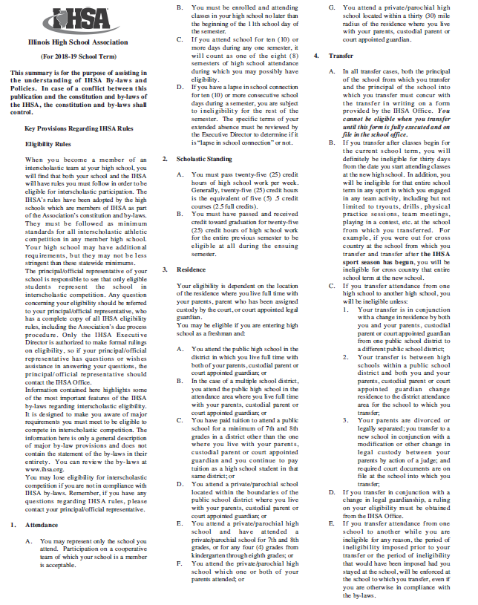

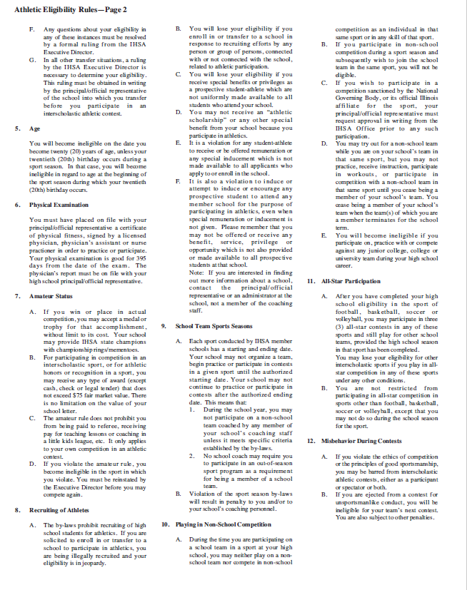

IHSA Link - <http://www.ihsa.org/documents/forms/current/elg_rules_lg.pdf>

|  |  |  |  |
| --- | --- | --- | --- |
| **2018/2019 Athletics and Activities Code of Conduct for Extracurricular Programs**  All students and their parents/guardians are expected to carefully review the following Athletics and Activities Code of Conduct in order to have a thorough understanding of the rigorous conduct standards expected of all District 300 students who participate in athletics and activities. The conduct code is based on the belief that participation in athletics and activities is a privilege and not a right. By accepting this privilege, students are expected to adhere to a higher standard of conduct. All District 300 sponsors, coaches, volunteers, and staff are committed to enforcing the Code of Conduct and the behavior expectations described in the District 300 Parent/Guardian Student Handbook.  Students who are selected for the privilege of membership on athletic teams and other school-sponsored activities must conduct themselves as exemplary representatives of their schools. In order to assure this conduct, student behavior guidelines are enforced in and out of season. The athletic and activity behavior code is in effect twelve months of the year, seven days a week, twenty-four hours a day, on and off school grounds until the end of the spring sport playoff season of a student’s senior year. Furthermore, members of teams and organizations who fail to abide by the rules for participation are subject to disciplinary actions. Likewise, all spectators – including parents/guardians – are expected at all times to use respectful language and behaviors; failure to do so may result in prohibited or limited attendance at school-sponsored athletic events or activities.  **Prohibited Activities and Violations of the Code of Conduct**  Prohibited activities include, but are not limited to, the following:   * Using, attempting to use, possessing, purchasing, selling, distributing or assisting another person in the use, attempted use, possession, purchase, sale or distribution of tobacco, tobacco products, electronic cigarettes, and/or look-alike drugs or alcohol * Using, attempting to use, possessing, purchasing, selling, distributing, being under the influence of or assisting another person in the use, attempted use, possession, sale or distribution of alcohol, drugs, controlled substances, other illegal mood-altering and/or performance enhancing drugs or chemicals, or any other substance used to obtain an altered mental state or “high” * Attending a gathering or riding in a vehicle where there is a report verified by school administration of minors drinking alcohol, minors having open alcohol, or minors’ drug use * Gross misconduct that is considered detrimental to his/her team or school. Some examples of gross misconduct may include, but are not limited to, illegal or criminal behavior, theft, fighting, vandalism, lying to school officials, academic dishonesty, falsifying information/signatures, hazing, bullying, cyber-bullying, poor sportsmanship, or intimidating acts.   Coaches, teachers, school staff, and any person from the public may report to the Athletic Director an alleged violation of the Code of Conduct at any time. After verifying the validity of the report, school authorities will investigate and follow appropriate due process procedures.  **Self-Reporting a Code of Conduct Violation**  A participant or parent/guardian may voluntarily report to the Athletic Director or other school authority a first-time Code of Conduct violation involving any of the prohibited activities listed above. The participant or parent will not be eligible for the terms of self-reporting after school authorities have initiated an investigation involving the violation. In other words, as soon as the participant or parent/guardian is aware that the participant has committed a code violation, they must immediately notify the athletic director or other school administrator. Self-reported incidents may result in further investigation by school authorities for verification or for school-related purposes involving other students.  Legitimate self-reported incidents will be recorded as a first offense, but the consequences will be held in abeyance provided the individual maintains behaviors consistent with the expectations and standards of the Athletic and Activities Code of Conduct and all District 300 rules and policies. Self-reporting may be used one time only in the participant’s academic career and only with regard to a first violation. If the student commits an additional violation of the Code of Conduct, he or she will be held accountable for consequences appropriate for a second offense.  **Violations of the Code of Conduct – Consequences**  All penalties involving this Code of Conduct are cumulative for the tenure of the student’s athletic career in School District 300. All penalties will be enforced at all levels. If a player is playing on more than one level or sport, the student will serve the consequence on both levels and sports. If the player is serving a consequence at one level or sport, the student may not participate at another level or sport.   1. **First Violation of Athletic Code:** Beginning with the first competition following notification of the violation, the student will lose eligibility from competition for twenty percent of the contests during their season (rounded up to the nearest whole number). Based on the circumstances of the violation, the nature of the sport or activity, and the decision of the Athletic Director and the coach, the student may still be expected to practice with the team, or the student may be excluded from practicing with the team. 2. **Second Violation of Athletic Code:** Beginning with the first competition following notification of the violation, the student will lose eligibility from competition for forty percent of the contests during their season (rounded up to the nearest whole number). If the violation involves a second occurrence of possessing or being under the influence of alcohol, tobacco, drugs, or other controlled substance, the student must participate in a certified alcohol or drug education program and provide documentation indicating successful completion. Based on the circumstances of the violation, the nature of the sport or activity, and the decision of the Athletic Director and the coach, the student may still be expected to practice with the team, orthe student may be excluded from practicing with the team. 3. **Third Violation of Athletic Code:** Beginning with the date of the violation notification, the student will lose eligibility from competition for one calendar year. Based on the circumstances of the violation, the nature of the sport or activity, and the decision of the Athletic Director and the coach, the student may still be expected to practice with the team, or the student may be excluded from practicing with the team. 4. **Any Additional Violations of Athletic Code:** The student will lose eligibility from all athletic activities for the remainder of his/her school career. The student will not be allowed to practice with any athletic team.   To calculate the number of contests the athlete must miss for any violation, the penalty will be based on the maximum number of regular season contests in the particular sport or activity. The total number of contests or events missed will vary with each sport or activity. If the violation requires the student to serve a suspension from school, the athletic penalty begins on the date of the suspension so that competitions missed while the student is suspended count toward the total competitions missed. If the violation occurs during the off-season, or the season length does not allow the athlete to successfully complete the suspension, the suspension period will carry over to the next season.  **All Student Athletic participants – Suspension and Appeal Procedures**  **School authorities shall follow these procedures for violations of the Athletic and Activities Code of Conduct:**   * Conduct an investigation to determine the extent and nature of allegations * Notify students verbally or in writing of the allegations * Provide students with an opportunity to respond to the allegations; students must provide their written statement on the school’s Student Incident Report form * If the results of the investigation indicate a violation of the Athletic and Activities Code of Conduct has occurred, notify students of the athletic and/or activities consequences. If the results of the investigation indicate a violation of Board Policy 7:190, Student Discipline, notify students of any additional school-related consequences * Provide written notification of the athletic and/or activities consequences to parents or guardians; also provide written notification of any additional school-related consequences   **School administration shall follow these guidelines for an appeal regarding an athletic suspension; appealing a suspension will not hold the terms of the athletic suspension in abeyance:**   * Parents/Guardians must submit a written suspension appeal request to the school’s Athletic Director or Principal within 3 days of the student athlete being suspended; the request must state the reason for the appeal, and the desired outcome expected * After a hearing is requested, school administration will contact D300 Central Office to validate the hearing request, establish the hearing date/time, and arrange for a hearing officer to conduct the athletic suspension hearing. * School administration communicates the date, time, location of the hearing to the student athlete and the student’s parent/guardian. The student athlete and his or her parent/guardian must be present at the hearing. * The hearing officer is responsible for conducting the hearing and submitting the information to the Superintendent or designee. The Superintendent or designee decides the outcome of the appeal based on the information provided by the hearing officer. * The decision of the Superintendent or designee is final and is communicated to the family by the Superintendent’s staff and/or by the hearing officer.   **HIGH SCHOOL ELIGIBILITY FOR EXTRACURRICULAR ACTIVITIES AND ATHLETICS**  **Fees:** There is a user’s fee assessed to each participant in each sport; athletic participation fees and obligations must be paid in full at least one week prior to the start of the athletic season. No student will be allowed to participate in athletic try-outs, practice, or competitions until all athletic registration and obligations have been completed and paid in full. Student athletes or student activity participants must pay for any school-issued equipment or uniform not turned in by the due date specified by the coach or sponsor. Each student athlete will be charged for a maximum of 2 high school sports per school year and/or a family cap of 4 high school sports per school year. No payment plan is offered for these types of charges.  **Lockers:** Students are responsible for removing everything from their athletic lockers when their season ends. The school is not responsible for students’ personal items left in locker rooms or inside lockers; neither the school nor the district will offer any type of reimbursement for personal items that are lost or stolen.  **Academics and Attendance:** According to the Illinois High School Association [IHSA], student IHSA participants must pass twenty-five credit hours of high school per week, or five .5 credit courses. Students must pass and earn full graduation credit for twenty-five credit hours per semester to be eligible for the following semester. Additional IHSA requirements can be found at ihsa.org. All student participants must be in attendance for at least half of the academic school day in order to participate in same-day contests or competitions. Students who are ineligible to participate in physical education classes will be ineligible for athletic participation. Supporting eligibility definitions and exceptions are determined by school administration.  **Physical Examinations:** Student athletes must provide a certificate of physical fitness issued by a licensed medical physician, physician’s assistant, or nurse practitioner not more than 395 days preceding any date of participation in any sport – including try-outs. High school student athletes are required by the IHSA to give permission to submit to a drug test at any time. Prior to athletic participation, all students are required to submit a waiver signed by a parent or guardian giving permission to drug test their child.  **Transportation:** Members of school teams or activities must travel to and from events in transportation scheduled for use by the Athletic Director or designee. The student participant may travel with a parent or guardian only if written permission has been obtained and pre-approved by the Athletic Director. When school-sponsored transportation has been provided, students are not allowed to drive themselves to and from events. Failure to use transportation as directed or to act appropriately while using transportation services will result in suspension from participation or competition for a length of time determined by the coach, sponsor, or Athletic Director.  **MIDDLE SCHOOL ELIGIBILITY FOR EXTRACURRICULAR ACTIVITIES AND ATHLETICS**  **Fees:** There is a user’s fee assessed to each participant in each sport; athletic participation fees and obligations must be paid in full at least one week prior to the start of the athletic season. No student will be allowed to participate in athletic try-outs, practice, or competitions until all athletic registration and obligations have been completed and paid in full. Student athletes or student activity participants must pay for any school-issued equipment or uniform not turned in by the due date specified by the coach or sponsor.  **Academics and Attendance:** Students must be passing at least five classes in order to be eligible for participation. All student participants must be in attendance for at least half of the academic school day in order to participate in same-day contests or competitions. Students who are ineligible to participate in physical education classes will be ineligible for athletic participation. Supporting eligibility definitions and exceptions are determined by school administration.  **Physical Examinations:** Student athletes must provide a certificate of physical fitness issued by a licensed medical physician, physician’s assistant, or nurse practitioner not more than one 395 days preceding any date of participation in any sport – including try-outs.  **Transportation:** Members of school teams or activities must travel to and from events in transportation scheduled for use by the Athletic Coordinator or designee. The student participant may travel with a parent or guardian only if written permission has been obtained and approved by the Athletic Coordinator or designee. Failure to use transportation as directed or to act appropriately while using transportation services will result in suspension from competition for a length of time determined by the coach, sponsor, and/or Athletic Coordinator. | | | |
|  |  |  |

**D300 Link -** [**https://d300.learning.powerschool.com/rebecca.polcik/athletics/cms_page/view/31473801**](https://d300.learning.powerschool.com/rebecca.polcik/athletics/cms_page/view/31473801)

**Online Registration Information - Student/Parent Information** following instructions:

* Go to https://dundeecrown.8to18.com (no www.)
* Click on “Create An Account” and enter your own email and create your own password. **(Please be sure to remember this password as you will use this for the years to come for all of your children.).**
* Click on “Begin Registration”
* “Select Activity”
  + Choose the sport your child will be trying for/participating in.
* “Select Participant”
  + Add a New Participant (or choose your child once created)
  + All information on this page is for the student, i.e. cell phone, email
* “Roster Details”
  + You may be asked for t shirt size
  + Height and Weight will be used for rosters
* “Primary Parent/Guardian Information”
  + Fill out the Parent information on the next page.
* “Physical Form”
  + If you need a form to take to the doctor you may print it here.
  + Remember your athlete must have a current physical in order to begin tryouts/practice.
* “Legal Form”
  + At this time by clicking on the boxes, you are agreeing and consenting to all information provided.
  + You may click on the form to read or print. Please note that when there is a parent/guardian and student check box- they must both be checked to move forward.
  + Please DO NOT turn in any forms filled out.
* “Summary”
  + At this time you can see what you have registered for.
  + Click on “Finish” to complete your registrations

**Online Registration - Coaches**

**Coaches will receive an email from the SYSTEM inviting them to the dashboard. They should click on the link within the email and log in using email and a password of their choice.**

***DO NOT CREATE ACCOUNT*.**

**Coaches have four tabs:**

**Roster Tab, Awards, Spirit-wear and Communication**

**Coaches will see Tryout List, Set Roster and have access to the Emergency Contact Report**

**Tryout List is all students who have registered for the sport (not by level)- the report is sorted in class/grade order.**

**UNDER ROSTER:**

**SET ROSTER, TRYOUT LIST, EMERGENCY CONTACT ,MANUAL AND AWARDS**

**Select Athletic Rosters- scroll down and select your sport/level**

**To Set a Roster:**

* To set a roster, go to the Athletic Roster tab
  + Select the sport
* At the top, you will select Set Roster
* A list of all registrants for that sport will appear- make sure you are on your sport and level-
  + You will check the box next to the registrant’s name and then check the blue box underneath that says “Move Selected to Roster”
* A prompt will appear stating that this will finalize the roster and ask if you if you want to continue
* Clicking “OK” will send an email message to the parent stating that their child has been selected to the level/team you have placed them on.
* No action is needed if an athlete is cut. You simply leave the name without checking the box.
* No email communication will be sent to any athlete that is cut.
* It is strongly suggested that you do not set your roster on 8to18 until you have verbally communicated the information to your athletes to avoid the parent receiving the information before the athlete.
* Clicking “Cancel” will bring you back to the previous page where you can choose to “delete” that particular athlete from your roster. Clicking delete does not remove them from the master list of athletes.
* It is important to note that absolutely no communication emails are sent until you click OK

You can have an athlete on multiple rosters- ie frosh, JV.

**TRYOUT LIST:**

**LIST OF ALL ATHLETES SIGNED UP**

**Emergency Contact Report**- can be printed and taken with or accessed via your phone/table in the event of an emergency.

**MANUAL REGISTRATION:**

**AWARDS:**

**Online Registration Forms:**

**Concussion Information Sheet**

A concussion is a brain injury and all brain injuries are serious. They are caused by a bump, blow, or jolt to the head, or by a blow to another part of the body with the force transmitted to the head. They can range from mild to severe and can disrupt the way the brain normally works. Even though most concussions are mild, **all concussions are potentially serious and may result in complications including prolonged brain damage and death if not recognized and managed properly.** In other words, even a “ding” or a bump on the head can be serious. You can’t see a concussion and most sports concussions occur without loss of consciousness. Signs and symptoms of concussion may show up right after the injury or can take hours or days to fully appear. If your child reports any symptoms of concussion, or if you notice the symptoms or signs of concussion yourself, seek medical attention right away.

**What can happen if my child keeps on playing with a concussion or returns too soon?**

Athletes with the signs and symptoms of concussion should be removed from play immediately. Continuing to play with the signs and symptoms of a concussion leaves the young athlete especially vulnerable to greater injury. There is an increased risk of significant damage from a concussion for a period of time after that concussion occurs, particularly if the athlete suffers another concussion before completely recovering from the first one. This can lead to prolonged recovery, or even to severe brain swelling (second impact syndrome) with devastating and even fatal consequences. It is well known that adolescent or teenage athletes will often fail to report symptoms of injuries. Concussions are no different. As a result, education of administrators, coaches, parents and students is the key to student-athlete’s safety.

**If you think your child has suffered a concussion**

Any athlete even suspected of suffering a concussion should be removed from the game or practice immediately. No athlete may return to activity after an apparent head injury or concussion, regardless of how mild it seems or how quickly symptoms clear, without medical clearance. Close observation of the athlete should continue for several hours. IHSA Policy requires athletes to provide their school with written clearance from either a physician licensed to practice medicine in all its branches or a certified athletic trainer working in conjunction with a physician licensed to practice medicine in all its branches prior to returning to play or practice following a concussion or after being removed from an interscholastic contest due to a possible head injury or concussion and not cleared to return to that same contest. In accordance with state law, all IHSA member schools are required to follow this policy. You should also inform your child’s coach if you think that your child may have a concussion. Remember it’s better to miss one game than miss the whole season. And when in doubt, the athlete sits out.

===============================================================================

**IHSA Protocol for Implementation of NFHS Sports Playing Rule for Concussion**

**“Any athlete who exhibits signs, symptoms, or behaviors consistent with a concussion (such as loss of consciousness, headache, dizziness, confusion, or balance problems) shall be immediately removed from the contest and shall not return to play until cleared by inappropriate health care professional.”**

The above language, which first appeared in all National Federation sports rule books for the 2010-11 school term, reflects a strengthening of rules regarding the safety of athletes suspected of having a concussion, but not a revision in primary responsibilities in these areas. Previous rules required officials to remove any athlete from play who was “unconscious or apparently unconscious.” This revised language reflects an increasing focus on safety, given that the vast majority of concussions do not involve a loss of consciousness. However, the revised language does not create a duty that officials are expected to perform a medical diagnosis. The change in rule simply calls for officials to be cognizant of athletes who display signs, symptoms, or behaviors of a concussion from the lists below and remove them from play.

**NOTE: The persons who should be alert for such signs, symptoms, or behaviors consistent with a concussion in an athlete include appropriate health-care professionals, coaches, officials, parents, teammates, and, if conscious, the athlete him/herself.**

**Definition of a Concussion**

A concussion is a traumatic brain injury that interferes with normal brain function. An athlete does not have to lose consciousness (be “knocked out”) to have suffered a concussion.

**Behavior or signs observed indicative of a possible concussion**

• Loss of consciousness

• Appears dazed or stunned

• Appears confused

• Forgets plays

• Unsure of game, score, or opponent

• Moves clumsily

• Answers questions slowly

• Shows behavior or personality changes

• Can’t recall events prior to or after the injury

**Symptoms reported by a player indicative of a possible concussion**

• Headache

• Nausea

• Balance problems or dizziness

• Double or fuzzy vision

• Sensitivity to light or noise

• Feeling sluggish

• Feeling foggy or groggy

• Concentration or memory problems

• Confusion

This protocol is intended to provide the mechanics to follow during the course of contests/matches/events when an athlete sustains an apparent concussion. For the purposes of this policy, appropriate health care professionals are defined as: physicians licensed to practice medicine in all its branches in Illinois and certified athletic trainers.

1. During the pre-game conference of coaches and officials, the official shall remind the head coaches that a school-approved

appropriate health care professional will need to clear for return to play any athlete removed from a contest for an apparent head injury.

1. The officials will have no role in determining concussion other than the obvious situation where a player is unconscious or apparently unconscious as is provided for under the previous rule. Officials will merely point out to a coach that a player is apparently injured and advise the coach that the player should be examined by the school-approved health care provider.

3. If it is confirmed by the school’s approved health care professional that the student did not sustain a concussion, the head coach may so advise the officials during an appropriate stoppage of play and the athlete may re-enter competition pursuant to the contest rules.

4. Otherwise, if an athlete cannot be cleared to return to play by a school-approved health care professional as defined in this

protocol, that athlete may not be returned to competition that day and is then subject to the IHSA's Return to Play (RTP) Policy before the student-athlete can return to practice or competition.

1. Following the contest, a Special Report shall be filed by the contest official(s) with the IHSA Office through the Officials Center.
2. In cases where an assigned IHSA state finals event medical professional is present, his/her decision to not allow an athlete to

return to competition may not be over-ruled.

**IHSA Sports Medicine**

**www.ihsa.org • general@ihsa.org • Phone: 309-663-6377 •**

**Return to Play (RTP) Policy**

**Background:** With the start of the 2010-11 school term, the National Federation of State High School Associations (NFHS) implemented a new national playing rule regarding potential head injuries. The rule requires “any player who exhibits signs, symptoms, or behaviors consistent with a concussion (such as loss of consciousness, headache, dizziness, confusion, or balance problems) shall be immediately removed from the game and shall not return to play until cleared by an appropriate health care professional.” In applying that rule in Illinois, it has been determined that only certified athletic trainers and physicians licensed to practice medicine in all its branches in Illinois can clear an athlete to return to play the day of a contest in which the athlete has been removed from the contest for a possible head injury.

**Policy:** In cases when an athlete is not cleared to return to play the same day as he/she is removed from a contest following a possible head injury (i.e., concussion), the athlete shall not return to play or practice until the athlete is evaluated by and receives written clearance from a licensed health care provider to return to play.

For the purposes of this policy, licensed health care providers consist of physicians licensed to practice medicine in all its branches in Illinois and certified athletic trainers working in conjunction with physicians licensed to practice medicine in all its branches in Illinois.

**Additional Concussion Resources**:

CDC – Heads Up: Concussions in HS Sports - <http://www.cdc.gov/concussion/HeadsUp/high_school.html>

CDC – Coaches Concussion Fact Sheet - <http://www.cdc.gov/concussion/pdf/coaches_Engl.pdf>

CDC – Parent Concussion Fact Sheet - <http://www.cdc.gov/concussion/pdf/Parents_Fact_Sheet-a.pdf>

Attached are the final documents D300 will use to be in full compliance with Return To Learn and Return To Play (RTL/RTP) Concussion Protocol Legislation.  These procedures have been added and approved by the board of education and added to the board documents.  More details and all forms are also found now in the administration procedures handbook.

Review on school compliance expectations:  Upon a student suffering a head injury, the athletic trainer or school personnel will initiate the concussion flow chart (attached) and fill out the concussion care plan (which includes the physician’s checklist - attached).  Once a student receives a concussion care plan document they are ineligible to participate in athletics until it is completed by a physician.  Upon a physician completing the concussion care plan it is reviewed and implemented by the concussion oversight committee.  This committee involves to the extent possible the athletic trainer, Athletic Director (FULL ADMIN NON-COACH), Assistant Principal of Instruction, nurse and physician who completed the concussion care plan.  They are to implement the physician’s plan of accommodations to learning, treatments, and next steps for return.  Upon physician’s directive, once the student has safely recovered from their injury they may return to normal learning.  One additional step is required to return to play and that is completion of the post-concussion consent form (attached).

### 7:305-AP Administrative Procedure – Program for Managing Student and Student Athlete Concussions and Head Injuries

The procedures outlined below are designed to facilitate communication to all vested parties in the event of a CUSD 300 student sustaining a concussion or traumatic brain injury. The outline is designed to provide a framework that ensures that parent(s)/guardian(s), coaches, teachers, counselors, and administration are aware of the student’s injury, as well as the student’s ongoing recovery. The outline is also designed to encourage communication between the necessary parties, and to allow for flexibility in timelines and interventions in order to meet the needs of the recovering student.

The Concussion oversight team is comprised of: Physician, Associate Principal of Curriculum and Instruction (APCI), School Nurse, and Athletic Director (AD) and Athletic Trainer (when applicable).

Please reference **7:305-E1 Concussion Flow Chart** to view a summary of the following procedures and protocols, **7:305-E2 for the Concussion Care Plan** and **7:305-E3 for the Post-Concussion Consent Form (RTP/RTL)**.

Steps to follow when a **student (non-athlete)** is suspected of a concussion or and/or demonstrating concussion like symptoms:

1. The school nurse is immediately informed of the student’s injury.
2. Parent(s)/guardian(s) is immediately contacted and provided with information regarding the concussion protocol as well as procedures for Return to Learn.
3. The school nurse completes the Concussion Care Plan and forwards to the parent(s)/guardian(s).
   1. STUDENT IS WITHHELD FROM ACEDEMIC PARTICIPATION UNTIL RETURN TO LEARN PROTOCOLS ARE MET (see below).
4. The nurse remains in contact with the student, parent(s)/guardian(s) as appropriate.
5. School nurse receives the Concussion Care Plan completed by the student’s physician.
6. School nurse forwards the Concussion Care Plan to counselor, school attendance secretary, and Associate Principal of Curriculum and Instruction.
   1. ANY FURTHER MEDICAL DOCUMENTATION FROM A MEDICAL PROFESSIONAL WILL BE RECEIVED BY THE SCHOOL NURSE.
7. The school nurse remains in contact with the student, parent(s)/guardian(s), and Associate Principal of Curriculum and Instruction as appropriate.
8. APCI collaborates with the counselor and teachers as necessary.
9. The APCI may collaborate with the counselor regarding possible interventions for the student.

**Return to Learn Protocol**

The **Return to Learn** protocol shall consist of the following actions by the counselor:

* + - 1. The counselor remains in contact with the student and parent(s)/guardian(s) as appropriate.
      2. The Counselor contacting and collaborating with student’s teachers, informing them of the injury.
      3. The counselor and teachers should collaborate on possible interventions for the student.
         1. They may include, but are not limited to:

1. Removal from PE classes (without the obligation to complete a “make up”) until cleared for return by the athletic trainer or other medical professional.
2. Extended time (additional days) to complete assignments in the classroom.
3. Breaks from class if necessary.
4. Other interventions deemed appropriate by the teacher and counselor.
   1. Initial plans will typically last up to 5 days, with extensions made by a medical professional as appropriate. However, the plan will be designed to meet the needs of each individual student.
5. The APCI will communicate to the counselor, and then to the teachers, that the student is to return to class under normal circumstances when notification is received.

Steps to follow when a **student athlete** is suspected of a concussion or and/or demonstrating concussion like symptoms:

1. Information is forwarded immediately to the school nurse and athletic trainer of the student’s injury.
2. Athletic trainer diagnoses or is made aware of a student with a possible concussion.
3. Athletic trainer contacts the parent(s)/guardian(s) with diagnosis.
4. Parent(s)/guardian(s) are provided with information regarding the concussion protocol as well as procedures for Return to Learn and Return to Play.
5. Athletic trainer completes the Concussion Care Plan.
6. Athletic Director, team coach, and school nurse are notified immediately of student’s injury.
   1. STUDENT IS WITHHELD FROM ATHLETIC PARTICIPATION UNTIL RETURN TO LEARN AND RETURN TO PLAY PROTOCOLS ARE MET.
7. Concussion care plan is emailed to school nurse and the nurse will forward the Concussion Care Plan to the parent(s)/guardian(s).
8. The athletic trainer will conduct Return to Play procedures on an ongoing basis.
9. The athletic trainer remains in contact with the student, parents, school nurse, coaches, and Athletic Director as appropriate.
10. School nurse receives the Concussion Care Plan completed by the student’s physician.
11. School nurse forwards the Concussion Care Plan to counselor, school attendance secretary, and Associate Principal of Curriculum and Instruction.
    1. ANY FURTHER MEDICAL DOCUMENTATION FROM A MEDICAL PROFESSIONAL WILL BE RECEIVED BY THE SCHOOL NURSE AND DISTRIBUTED TO THE ATHLETIC DIRECTOR AND APCI.
12. The school nurse remains in contact with the athletic trainer, student, parent(s)/guardian(s), AD, and APCI as appropriate.
13. Athletic Director receives the Concussion Care Plan (or any other pertinent medical information from the school nurse).
14. AD remains in contact with team coaches, student, athletic trainer, and parents as appropriate.
15. Associate Principal of Curriculum and Instruction receives Concussion Care Plan (or any other pertinent medical information from the school nurse).
16. APCI collaborates with counselor as necessary.
17. The APCI may collaborate with the counselor regarding possible interventions for the student.

**Return to Learn and Return to Play Protocols**

The **Return to Learn** protocol shall consist of the following actions by the counselor:

* + - 1. The counselor remains in contact with the student and parent(s)/guardian(s) as appropriate.
      2. The Counselor contacting and collaborating with student’s teachers, informing them of the injury.
      3. The counselor and teachers should collaborate on possible interventions for the student.
         1. They may include, but are not limited to:

Removal from PE classes (without the obligation to complete a “make up”) until cleared for return by the athletic trainer or other medical professional.

Extended time (additional days) to complete assignments in the classroom.

Breaks from class if necessary.

Other interventions deemed appropriate by the teacher and counselor.

* + - * 1. Initial plans will typically last up to 5 days, with extensions made by a medical professional as appropriate. However, the plan will be designed to meet the needs of each individual student.
      1. The APCI will communicate to the counselor, and then to the teachers, that the student is to return to class under normal circumstances when notification is received.
      2. The athlete may be withheld from athletic participation for one year. However, the student may return to play when the following have been completed:
         1. Return to Learn protocol and procedures
         2. Return to Play protocol (see below)

The **Return to Play** protocol shall consist of the following:

1. Physician clearance has been received
2. Parental consent form (**7:301-E3 - Post-Concussion Consent Form RTL/RTP**) has been signed by parent(s)/guardian(s) has been received.
3. Upon receipt of permission to return to play (from the athletic trainer or another medical professional) paperwork will be routed through the school nurse, AD, and APCI.
4. The AD will communicate to coaches that the student may return to play.

LEGAL REF.: 105 ILCS 5/10-20.54.

(1) The Youth Sports Concussion Safety Act, 105 ILCS 5/22-80, added by P.A. 99-

245; (2)105 ILCS 5/10-20.54; (3) 105 ILCS 25/1.15, added by P.A. 98-1011.

CROSS REF.: 4:170 (Safety), 7:300 (Extracurricular Activities)

DATED: July 2016

### 

### 7:301-E2 Exhibit – Concussion Care Plan

Date:________________

Dear Treating Physician,

Your Patient ___________________________________ is a CUSD 300 student and was injured with symptoms indicating a possible concussion. A baseline ImPACT test was completed and a post ImPACT test will be given once the student is symptom free for 24 hours and is fully active cognitively.

**History:** ____________________________________________________________________________________________________________

**Symptoms (Place an X next to all present symptoms):**

|  |  |  |  |  |  |
| --- | --- | --- | --- | --- | --- |
| **Symptom** | **Yes** | **No** | **Symptom** | **Yes** | **No** |
| Headache |  |  | Confusion |  |  |
| Dizziness (Eyes Open) |  |  | Blurred Vision |  |  |
| Dizziness (Eyes Closed) |  |  | Sleep Disturbances |  |  |
| Nausea |  |  | Memory Loss (Anterograde) |  |  |
| Fatigue |  |  | Memory Loss (Retrograde) |  |  |
| Irritable |  |  | Pain |  |  |
| Sensitivity to Light |  |  | Loss of Consciousness |  |  |
| Sensitivity to Sound |  |  | Other: |  |  |

**FOR PHYSICIAN TO COMPLETE:**

**Diagnoses:**

______ Concussion _______ Head Trauma ________ No Injury

CUSD 300 recognizes the impact of a concussion and supports full cognitive and physical rest.

**Please circle the Return to Learn step you prescribe for your patient to begin:**

|  |  |  |  |
| --- | --- | --- | --- |
| **Step** | **Intensity** | **Cognitive Activity** | **Suggested Accommodations** |
| 1 | No Activity, No School | Rest |  |
| 2 | Begin Accommodated School Days | -Allow accommodations for symptoms  -1/2 day of school or to allow to rest in nurses office  -All classwork done at home at 30 minute intervals |  |
| 3 | Full day of school with Accommodations | -Allow accommodations for symptoms  -Attend all classes but rest in nurses if symptomatic  -Begin classwork as symptoms permit  -Athlete will take post injury ImPACT Test |  |
| 4 | Students return to full cognitive activity | -Full day of school  -Full classwork and resume physical education  Athletes will complete the return to play protocol |  |

**Please check all that apply:**

__________ CUSD 300 must contact you to progress with Return to Learn and Return to Play protocols.

__________ CUSD 300 can progress with the Return to Learn / Return to Play steps as symptoms dictate, but student must be evaluated by your office before full release.

__________ Once the Return To Learn and Return to Play protocols are completed, patient can be released to full cognitive and physical activity. CUSD 300 will contact you when patient is released (no further visit necessary).

**Contact Information and Signature:**

__________________________ ___________________________________ ____________________________

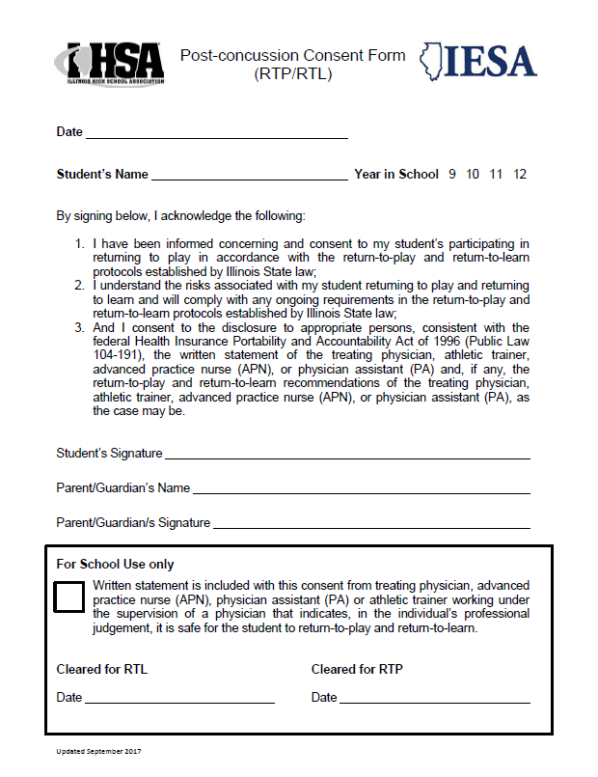

IHSA Link - <http://www.ihsa.org/documents/forms/current/Post-concussion%20Consent%20Form%20(RPT-RTL).pdf>

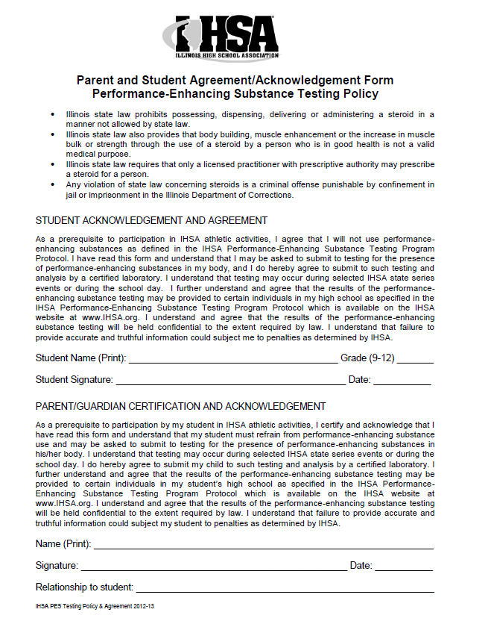

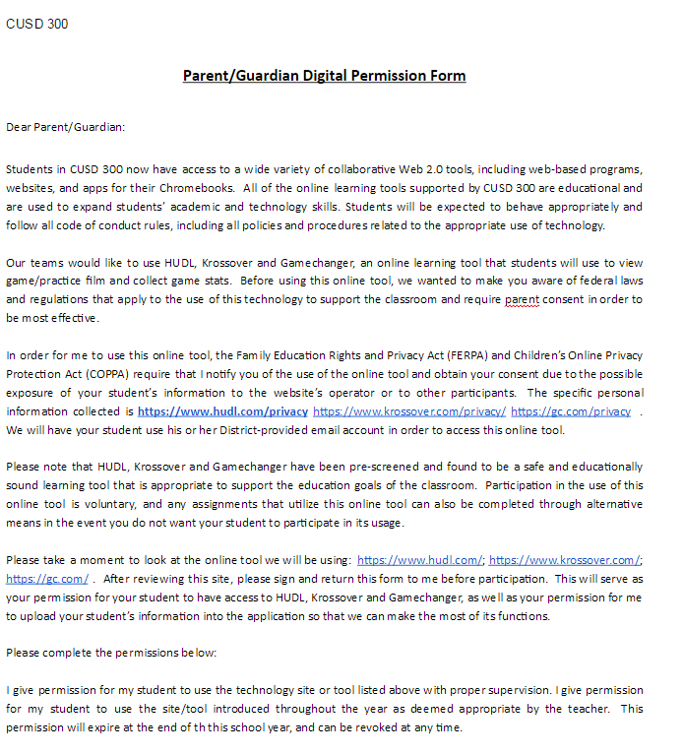

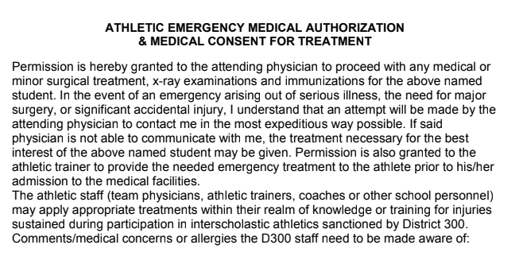

**Communication Form**

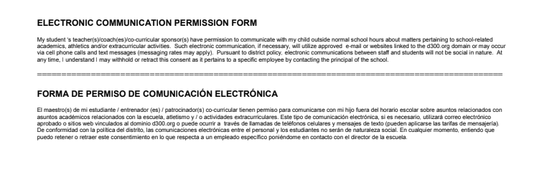

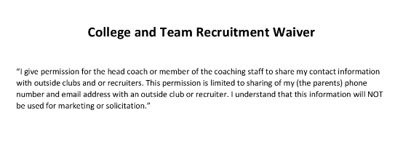

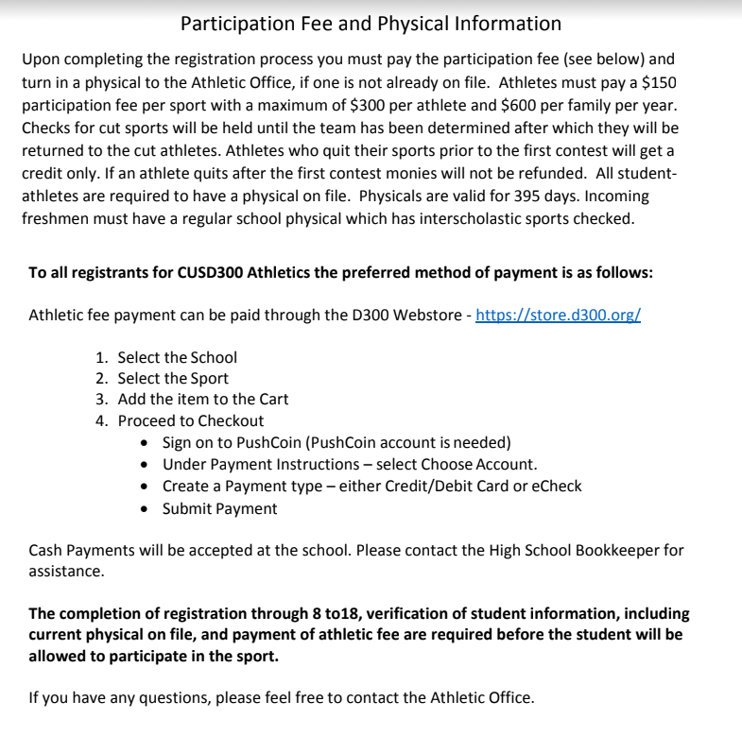

**COMMUNITY UNIT SCHOOL DISTRICT 300**

**ANTI-BULLYING-HAZING**

School District’s mission is to create and sustain a safe and positive educational environment that will help each student grow to his or her potential intellectually, socially, emotionally, and physically, to become a lifelong learner who is a responsible, contributing member of our community. Therefore bullying and hazing are forms of dangerous and disrespectful behaviors and will not be tolerated.

e. 7:190, Student Discipline. This policy prohibits students from engaging in hazing, bullying, or any kind of aggressive behavior that does physical or psychological harm to another or any urging of other students to engage in such conduct; prohibited conduct includes any use of violence, force, noise, coercion, threats, intimidation, fear, harassment, or other comparable conduct.

Bullying is unwanted, aggressive behavior among school aged children that involves a real or perceived power imbalance. The behavior is repeated, or has the potential to be repeated, over time. (www.stopbullying.gov)

There are three (3) types of bullying:

**Verbal bullying** is saying or writing mean things. Verbal bullying includes:

* Teasing
* Name-calling
* Inappropriate sexual comments
* Taunting
* Threatening to cause harm

**Social bullying**, sometimes referred to as relational bullying, involves hurting someone’s reputation or relationships. Social bullying includes:

* Leaving someone out on purpose
* Telling other children not to be friends with someone
* Spreading rumors about someone
* Embarrassing someone in public

**Physical bullying** involves hurting a person’s body or possessions. Physical bullying includes:

* Hitting/kicking/pinching
* Spitting
* Tripping/pushing
* Taking or breaking someone’s things
* Making mean or rude hand gestures

**Cyber bullying** is bullying that takes place using electronic technology. Electronic technology includes devices and equipment such as cell phones, computers, and tablets as well as communication tools including social media sites, text messages, chat, and websites.

Illinois state laws that cover bullying:

105 Illinois Compiled Statutes §5/10-20.14 – Student discipline policies

If you are being bullied or you know someone that is being bullied, report your information to the District 300 Safe School Tip Line at 847-551-TIPS (8477) or submit information via email at [SafeSchoolTipLine@d300.org](mailto:SafeSchoolTipLine@d300.org). You will remain anonymous, prevent school violence, and action will be taken by school authorities.

“Hazing” refers to any activity expected of someone joining a group (or to maintain full status in a group) that humiliates, degrades or risks emotional and/or physical harm, regardless of the person's willingness to participate whether conducted on or off school property.

The following are some examples of hazing divided into three categories: subtle, harassment, and violent. It is impossible to list all possible hazing behaviors because many are context-specific. While this is not an all-inclusive list, it provides some common examples of hazing traditions.

**Subtle Hazing** are behaviors that emphasize a power imbalance between new members/rookies and other members of the group or team. Termed “subtle hazing” because these types of hazing are often taken-for-granted or accepted as “harmless” or meaningless. Subtle hazing typically involves activities or attitudes that breach reasonable standards of mutual respect and place new members/rookies on the receiving end of ridicule, embarrassment, and/or humiliation tactics. New members/rookies often feel the need to endure subtle hazing to feel like part of the group or team. (Some types of subtle hazing may also be considered harassment hazing).

* Deception
* Assigning demerits
* Silence periods with implied threats for violation
* Deprivation of privileges granted to other members
* Requiring new members/rookies to perform duties not assigned to other members
* Socially isolating new members/rookies
* Line-ups and Drills/Tests on meaningless information
* Name calling
* Requiring new members/rookies to refer to other members with titles (e.g. “Mr.,” “Miss”) while they are identified with demeaning terms
* Expecting certain items to always be in one's possession

**Harassment Hazing** are behaviors that cause emotional anguish or physical discomfort in order to feel like part of the group. Harassment hazing confuses, frustrates, and causes undue stress for new members/rookies. (Some types of harassment hazing can also be considered violent hazing).

* Verbal abuse
* Threats or implied threats
* Asking new members to wear embarrassing or humiliating attire
* Stunt or skit nights with degrading, crude, or humiliating acts
* Expecting new members/rookies to perform personal service to other members such as carrying books, errands, cooking, cleaning etc.
* Sleep deprivation
* Sexual simulations
* Expecting new members/rookies to be deprived of maintaining a normal schedule of bodily cleanliness.
* Be expected to harass others

**Violent Hazing** are behaviors that have the potential to cause physical and/or emotional, or psychological harm.

* Forced or coerced alcohol or other drug consumption
* Beating, paddling, or other forms of assault
* Branding
* Forced or coerced ingestion of vile substances or concoctions
* Burning
* Water intoxication
* Expecting abuse or mistreatment of animals
* Public nudity
* Expecting illegal activity
* Bondage

**Illinois Hazing Law:**

**§ 720 ILCS 120/5. Hazing**

**Reporting Bullying and/or Hazing**

* Any person who believes he or she has been the victim of hazing or any person with knowledge or belief of conduct which may constitute bullying and/or hazing shall report the alleged acts immediately to a Dundee-Crown High School staff member.
* The staff member will assist the student in reporting to a Dundee-Crown High School administrator or other district personnel.
* Teachers and other school staff who witness acts of bullying or receive student reports of bullying are required to promptly notify Dundee-Crown High School administration.
* The school district will act to investigate all complaints of hazing and will discipline or take appropriate action against any student, teacher, administrator or other school district employee, contractor or volunteer who is found to have violated School District 300 Code of Conduct.

**Possible Consequences**

* Penalties may include, but not limited to, graduation ceremony suspension, probation, team suspension, or dismissal.
* Any student who retaliates against another for reporting bullying will also be subject to consequences.
* Any participant who chooses not to follow the above behaviors will be subjected to consequences on a case by case matter.
* This applies to bullying and/or hazing behavior that occurs on or off school property and during and after school hours.

**Resources:**

* www.stopbullying.gov
* www.stophazing.org

**Dundee-Crown Athletic Booster Club**

**Sports Financial Assistance Request ­ 2018-­2019**

Date Prepared: ____/_____/_____ Sport: ___________________________ Gender: Boys Girls Season: F W S

Name of Coach Submitting Request: _____________________________

Coaches Phone Number: _______­_______­________ Email ____________________@_____________.___________

1. Item (s) or Service Requested­ be very specific; attach any quotes or catalog pages of your items:_____________________________________________________________________________________

Total Amount of Request (Include Taxes and Shipping) $____________________

**2. Why do you need this Item or Service? (Please explain in detail)**

__________________________________________________________________________________________

**3. Please Answer all Questions and Provide Supporting Documentation**

**a. When was this item or service last purchased for this sport? ________________________________________**

**b. Do you plan to do any fundraising this year for this item or service? If yes, describe and provide the estimated funds to be raised. ______________________________________________________________________________**

**c. How much money is currently in your SAF Account? _____________________________**

**d. Concessions is 100% successful based on volunteers. How will you, as the coach, encourage your parents to volunteer for Concessions in 2018-­2019?**

__________________________________________________________________________________________

*Booster Club Use Only*

Athletic Director's Recommendation: ____________________________________Date _____/_______/______

Amount Athletics Budget will Cover: $______________AD Initials: ______

Notes: __________________________________________________________________________________________

Submit todcboostertreasurer@gmail.com

Amount Approved: $__________________Reason Denied: ________________________________________________

Date: ____/_______/_________Board Meeting Date: _____/______/______Ck #________Inv #:____________________

Submit [to-dcboostertreasurer@gmail.com](mailto:to-dcboostertreasurer@gmail.com)

Online link - [**https://d300.learning.powerschool.com/rebecca.polcik/athletics/cms_page/view/38079505**](https://d300.learning.powerschool.com/rebecca.polcik/athletics/cms_page/view/38079505)

**Community Unit School District 300 – ONLINE (Frontline)**

**Athletic Head and Assistant Coach Summative Evaluation – Season 2017-2018**

*This evaluation will be completed by the supervising administrator. When this evaluation pertains to an assistant coach, the head coach may provide input to the supervising administrator.*

Coach Name

Sport: Level: School Year:

Mark each item according to the following:

ME: Meets expectations D: Does not meet NA: Not applicable

I. Planning and Preparation

1. Cares for equipment ME D NA

2. Organizes staff responsibilities ME D NA

3. Organizes practices ME D NA

4. Publishes practice schedules and adheres to practice timelines ME D NA

5. Develops and employs an objective tryout procedure for ME D NA

determining squad members, keeps record of such, and advises

athletes ahead of time what those criteria will be

6. Demonstrates knowledge of skills needed for sport ME D NA

7. Shows evidence of pre and post season preparation ME D NA

**Overall Domain ME D NA**

II. Environment

1. Supervises field or court, athletic facilities, trips and/or ME D NA

locker rooms

1. Creates an environment of respect and rapport ME D NA
2. Manages student behavior in a consistent and fair basis ME D NA
3. Represents the team in a positive manner. ME D NA
4. Demonstrates positive conduct during practices and ME D NA

competitions

**Overall Domain ME D NA**

III. Instruction

1. Discusses all training/behavioral guidelines with the team ME D NA

throughout the season

1. Provides constructive feedback to students ME D NA
2. Provides grade level developmentally appropriate practice ME D NA

instruction

1. Demonstrates flexibility and responsiveness to situations ME D NA
2. Teaches the skills required for the sport ME D NA
3. Communicates with student athletes ME D NA

**Overall Domain ME D NA**

(continued on reverse side)

IV. Professional Responsibilities

1. Attends coaches meetings ME D NA
2. Attends rules meetings ME D NA
3. Attends clinics when possible ME D NA
4. Adheres to District 300 policies, eligibility reports, rosters, ME D NA

end of season reports, etc.

5. Makes Athletic Director aware of all personnel assisting with ME D NA

coaching responsibilities prior to their involvement with the squad

including student teachers, staff members and parents

6. Communicates with staff ME D NA

7. Communicates with coaching staff ME D NA

1. Communicates with administration ME D NA
2. Communicates with parents/families ME D N/A

**Overall Domain ME D NA**

Areas of Strength:

Recommendation/Goals:

Coach’s Comments:

Recommendations for Next Year:

Renewal

Non-Renewal

____________________________ ________________________

Signature of Head Coach Signature of Administrator

____________________________ _____________________

Signature of Assistant Coach Date

**Dundee-Crown Fall, Winter and Spring Online Sport Survey 2018-2019**

**In our athletic programs, we strive for improvement among the players, coaches and athletic department. We would like your honest feedback to assist us in this process. Please rate your coach(es) in the areas listed below.**

1. Choose the sport in which you participated in?

2. On which level did you participate?

3. What year will you graduate?

**Education Priorities**

4. Were academic standards enforced for athletes?

5. Did the coaches make you aware of the weekly grade checks and share the reports with you?

6. Were athletes held to code of conduct standards?

**Safety, Health and Conditioning**

7. Were safe competitive techniques taught?

8. Were safe practice sessions conducted?

9. How would you rate our overall athletic training coverage? (Visibility, communication, etc.)

**Equipment, Facilities, and Management**

10. Assess the condition of the equipment in this sport.

11. Assess the cleanliness of the athletic facilities?

**Team Selection, Climate, Core Values**

12. Did you understand your role on the team?

13. Did you feel recognized for effort and hard work?

14. Do you feel you made meaningful contributions to the team?

15. Do you feel that all team members contributed to the team?

16. Do you feel that player selection was based on skill, knowledge, and physical capabilities?

17. Do you feel the players were treated fairly and equitably?

18. Do you feel the coaches monitored the conduct of athletes during practice, contests, and in the locker areas?

19. Did the coach model appropriate behavior?

20. Did you feel the coach adequately communicated with players?

21. Was your coach knowledgeable about the sport?

22. Did your coach motivate you to give your best?

23. Were practices organized? (Drills, time management, etc.)

24. Did the coach counsel players concerning playing time?

25. Did the coach counsel players concerning plans after high school?

26. Did the coach insist upon good sportsmanship?

27. Did the coach treat all players fairly?

28. Does your coach encourage you to participate in other high school sports?

29. How would you rate your overall experience in this sport?

30. How would you rate the overall quality of Dundee-Crown High School's athletic program?

31. How would you rate the communication from the athletic office?

Do you have any additional comments regarding your experience in this sport?

Please be professional and constructive in your response.

**Inventory – Google Doc**

<https://docs.google.com/forms/d/1YX-b6kJhsXHUVcwB8PglbHp3anqrqDuZBNyN0jJbCwU/viewform?edit_requested=true>

2017-18 DC Fall Athletics - Equipment Inventory

Please select the sport and then describe the equipment being counted. After you fill out the fields, please hit submit, then submit another response and repeat the process until you have counted all your equipment.

* Required

Sport? *

Choose

Football

Girls' Volleyball

Boys Cross Country

Girls Cross Country

Boys Golf

Girls Golf

Boys Soccer

Girls Tennis

Girls Swimming

Cheerleading

Dance/Poms



Describe the equipment. *

Your answer



Quantity of Equipment. *



Your answer

**OBSERVANCE OF THE NATIONAL ANTHEM**

According to Section 4 of the Federal Flag Code, “There is only one proper way to conduct themselves at athletic events during the playing of the National Anthem. The code states that an individual should stand, face the flag, and place his or her right hand over the heart.  Men should remove hats (helmets) and hold them in their right hands over their left shoulder so that their hand is over their heart. Holding a helmet by the side, shuffling of the feet, chewing gum, talking to teammates, facing away from the flag, or cheering prior to the completion of the entire song are inappropriate and disrespectful to the flag and what it represents."

We personally like to hear our teams sing it loudly along with our school fight song as displays of respect and pride.

**Chargers Fight Song**

On Chargers Dundee Crown,

We proudly meet our foe.

Go Chargers Dundee Crown,

To Victory we know.

Win Chargers, Red and Blue,

Defenders of our name!

And no matter where we

GO, GO, GO!

FIGHT, FIGHT, FIGHT!

Onward to victory.

***I Am the Flag of the United States of America***

***I am the flag of the United States of America.***

***My name is Old Glory.***

***I fly atop the world’s tallest buildings.***

***I stand watch in America’s halls of justice.***

***I fly majestically over institutions of learning.***

***I stand guard with power in the world.***

***Look up at me and see me.***

***I stand for peace, honor, truth, and justice.***

***I stand for freedom.***

***I am confident.***

***I am arrogant.***

***I am proud.***

***When I am flown with my fellow banners,***

***my head is a little higher,***

***my colors a little truer.***

***I bow to no one!***

***I am recognized all over the world.***

***I am worshipped – I am saluted.***

***I am loved – I am revered.***

***I am respected – and I am feared.***

***I have fought in every battle of every war***

***for more than 200 years.***

***I was flown at Valley Forge, Gettysburg,***

***Shiloh, and Appomattox.***

***I was there at San Juan Hill,***

***in the trenches of France,***

***in the Argonne Forest, Anzio, Rome***

***and the beaches of Normandy.***

***Guam, Okinawa, Korea, Saigon, Vietnam all know me.***

***I was there.***

***I led my troops.***

***I was dirty, battle worn and tired,***

***but my soldiers cheered me***

***and I was proud.***

***I have been burned, torn, and trampled***

***on the streets of countries I have helped set free.***

***It does not hurt, for I am invincible***

***I have been soiled upon, burned, torn***

***And trampled on the streets of my country.***

***When it is by those whom I’ve served in battle – it hurts.***

***But I shall overcome – for I am strong.***

***I have slipped the bonds of Earth***

***and stood watch over the uncharted frontiers of space.***

***I have borne silent witness***

***to all of America’s finest hours,***

***but my finest hours are yet to come.***

***When I am torn into strips***

***and used as bandages***

***for my wounded comrades on the battlefield,***

***when I am flown a half-mast to honor my soldier,***

***or when I lie in the trembling arms***

***of a grieving parent at the grave***

***of their fallen son or daughter,***

***I am proud.***

***My name is Old Glory***

***Lord May I Wave***

***Dear God in Heaven***

***Lord May I wave - author unknown***